  - Implementing the INSIEME portal according to the patients and caregivers’ point of view

Ivana Truccolo†
ANGOLO OdV, Italian Association of Long-term Cancer Survivors, President
ivanatruccolo@gmail.com
Virginia Gerlero
Venetian Cluster
virginia.gerlero@venetiancluster.eu
Flavio Rizzolio
Department of Molecular Sciences and Nanosystems, Ca’ Foscari University of Venice
flavio.rizzolio@unive.it

Vincenzo Canzonieri
Anatomia Patologica, Centro di Riferimento Oncologico di Aviano (CRO) IRCCS,
Department of Medical, Surgical and Health Sciences, University of Trieste
vcanzonieri@cro.it

Figure 1: Official logotype from the project

ABSTRACT / POVZETEK
†Corresponding name

Permission to make digital or hard copies of part or all of this work for personal or classroom use is granted without fee provided that copies are not made or distributed for profit or commercial advantage and that copies bear this notice and the full citation on the first page. Copyrights for third-party components of this work must be honored. For all other uses, contact the owner/author(s).
Information Society 2021, 4–8 October 2021, Ljubljana, Slovenia© 2021 C
opyright held by the owner/author(s).
The 2030 Agenda for Sustainable Development highlights that the spread of information and communications technology and global interconnectedness has great potential to accelerate human progress, to bridge the digital divide and to develop knowledge societies.
In the health sector as well, technology can help people tracking and controlling their own health information and make informed decisions about their health but only at two conditions:

- Technology must be really accessible
- Health information must be really understandable, scientifically correct and aligned with the reality
The project Interreg Italia Slovenia ISE-EMH aims to create a health portal integrating useful information about health topics and health facilities related to a specific interregional area both in Slovenian and Italian languages. INSIEME is the name of the portal.

KEYWORDS
Oncology, health topics, health facilities, patients, caregivers, cancer survivors, digital health
- Introduction
The contribution of the Ca' Foscari University, partner of the project, was to integrate into this portal INSIEME some categories of useful resources related to the cancer topic. The selection of these categories was made with the contribution of a cancer survivors and caregivers association. It is a fact that very often a patient relies on the search engines algorithms to find out the information he/she needs. But it happens that resources ranked as not important by the search engines are actually very useful to him/her. So, the point of view of some individuals, both cancer patients and caregivers, was the main guide to identify the resources to be listed in the portal. Not only the management of the cancer disease is important to a patient but also his/her mental condition, his/her wellness and practical things such as accommodation and work related issues. There are good examples of this integration

2 Results
A preliminary search was made to find out informational resources about cancer to widen the spectrum of categories and services. Then we tried to categorize the cancer services related both to the area of the metropolitan city of Venice and the Region Friuli Venezia Giulia.
In addition to basic services, the search has highlighted the following complementary categories:
- Hospital services
- Social services
- Physiotherapy services
- Physical activities opportunities and related opportunities
- Psychological services
- Accommodation services for patients and/or family members
- Information and counselling services about health topics and patients' rights
- Administrative services
- Local social and health services – screening
- Local social and health services - palliative care
- Voluntary associations
- Independent information on cancer
- Information on fake news

For each category, a minimum of 5 websites was listed if available.
Below a brief summary of the research carried out through the consultation of a large number of websites.
- Hospital health services: nº 15 facilities were found in the province of Venice and nº 24 in Friuli Venezia Giulia.
- Social services: the individual municipalities of the province of Venice and the Region of Friuli Venezia Giulia offer social services to citizenship
- Physiotherapy and rehabilitation services: as far as the province of Venice is concerned, the two main departments of Physical Medicine and Rehabilitation of the San Giovanni e Paolo Hospital of Venice and the Angelo Hospital of Mestre have been described. In addition, the local rehabilitation and physical therapy services in the different health and social authorities have been listed. About the Friuli Venezia Giulia Region, the two University & health agencies of Udine and Trieste have been described, in addition to health services of home rehabilitation
- Psychological services: the family counselors are available in the metropolitan area of Venice and in the Friuli Venezia Giulia Region. In addition, the ANT Foundation 1978 Onlus has been described that offers psychological support at home to all patients.
- Accommodation services: accommodation facilities near the main hospitals have been described with the information of their websites. Some of them are free, others offer low price accommodation. In addition, the channels of Airbnb and Booking.com have been reported;
- Information and advocacy services for the protection of patients' rights: for both areas were listed the main services
- Administrative services
- Local health and social services - Screening: the cancer prevention opportunities of the Friuli Region has been listed
- Local social and health services - Palliative care: the Health District of Mirano and Dolo has been reported with regard to palliative care services;
- Specialized voluntary associations through the useful webtool of Oncoguida, the large number of voluntary associations operating in the area of Venice and Friuli can easily be identified.
- websites with dealing with current information about cancer topics and tools to easily discover fake news were also described
- websites with patients stories or personal narrations were also indicated as they are very helpful to patients wellness.
Last but not least the websites related to all the hospitals and Health Comprehensive Centers of the Friuli Venezia Giulia Region and Venice area were listed and described.

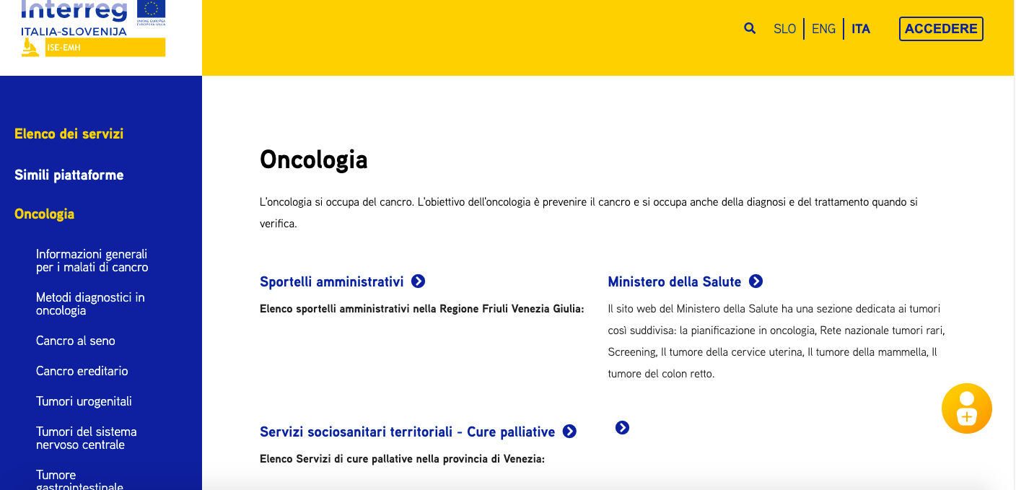

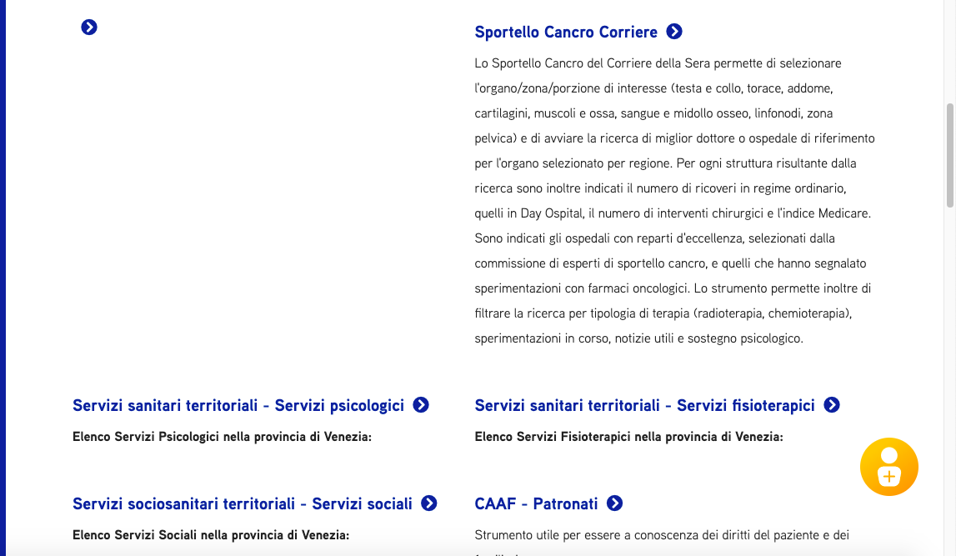
Figure 2: View of the Oncology section in the INSIEME portal

3 Conclusions
The different categories of resources integrated into the INSIEME portal are not exhaustive of course. They just give a hint of the importance of taking into account both informational and practical resources and involving patients and caregivers in the building of digital health portals
ACKNOWLEDGMENTS
The paper was supported by the ISE-EMH project funded by the program: Interreg V-A Italy-Slovenia 2014-2020. We thank the patients and caregivers that help to identify the resources listed in the portal.
REFERENCES
[] WHO, Draft Global strategy on Digital Health 2020-2025. Available at http://bit.do/fLkpp
[2] Australia’s health 2018, available at http://bit.do/fLkoA
[3] Truccolo I, Cipolat Mis, C, De Paoli P (eds), Insieme ai pazienti. Costruire la Patient Education nelle strutture sanitarie. Il Pensiero scientifico, 2016
[4] Kildea J, Battista J, Cabral B, Hendren L, Herrera D, Hijal T, Joseph A. Design and Development of a Person-Centered Patient Portal Using Participatory Stakeholder Co-Design. J Med Internet Res. 2019 Feb 11;21(2):e11371. doi: 10.2196/11371
[5] Oncoguida, available at http://www.oncoguida.it/html/home.asp

WHO, Draft Global strategy on Digital Health 2020-2025. Available at http://bit.do/fLkpp
Australia’s health 2018, available at http://bit.do/fLkoA
Truccolo I, Cipolat Mis, C, De Paoli P (eds), Insieme ai pazienti. Costruire la Patient Education nelle strutture sanitarie. Il Pensiero scientifico, 2016 4 Kildea J, Battista J, Cabral B, Hendren L, Herrera D, Hijal T, Joseph A. Design and Development of a Person-Centered Patient Portal Using Participatory Stakeholder Co-Design. J Med Internet Res. 2019 Feb 11;21(2):e11371. doi: 10.2196/11371
Oncoguida, available at http://www.oncoguida.it/html/home.asp

