**DEMOGRAPHIC PROCESSES AND THEIR ROLE IN FULFILMENT OF THE OBJECTIVES OF AGENDA 2030**

*Dr.sc. Sami Behrami Msc. Fadil Bajraktari*

Kosovo Environment Protection Agency Kosovo Environment Protection Agency

Str. Luan Haradinaj (ex- media palace) Str. Luan Haradinaj (ex- media palace)

14th floor, 10000 Pristina 14th floor, 10000 Pristina

Tel:+381 (0) 38 33 236, mob: +377 (0) 44 146 861 Tel: mob: +377 (0) 44 146 861

E-mail: [samibehrami@gmail.com](mailto:samibehrami@gmail.com), E-mail: [fadilbajraktari@gmail.com](mailto:fadilbajraktari@gmail.com),

**Abstract:**

**Demographic processes throughout the whole history of the development of human society were an important factor of development and survival whereas for many fields are also crucial. Demographic phenomena are one of the main challenges for sustainable development as they have an impact on a wide range of issues including sustainable development.**

**One of the most important elements of sustainable development which is also expressed in the most important document of the contemporary concept of sustainable development which is Agenda 2030 and Agenda 21., are demographic trends and factors, therefore, as such, they should be incorporated in the general analyses by exploring the interaction between demographic trends and sustainable development.**

**Demographic components are the basis for progress, survival and development for all societies/humanity and ignoring this basic truth sooner or later brings negative results in other areas of life.**

**However, regardless of which socio-economic or environmental sector is in question, the path to sustainable development is the people so it is imperative that the problems and demographic potential be taken into account if we are to find answers to the demand for sustainability in economic, social, ecological, etc. development.**

**Thus for the sustainable development of countries, regions, municipalities, etc., it is necessary in the first place to ensure demographic sustainability.**

***Keywords****:* demographic processes, demographic sustainability, sustainable development, etc.

1. **INTRODUCTION**

In the perspective of the development and progress of human society, the concept of sustainable development is given the main attention, transforming sustainability as the most important part of development policies of all spheres of life whether those of global, regional or local levels.

In the contemporary literature there are various definitions of sustainable development, however, the most widespread

and comprehensive definition is the definition of the World Commission on Environment and Development which

defines the sustainable development as: "..... development that meets the requirements of the current generation and at the same time does not endanger the opportunities of future generations to meet their own requirements” where special importance is given to the third generation.

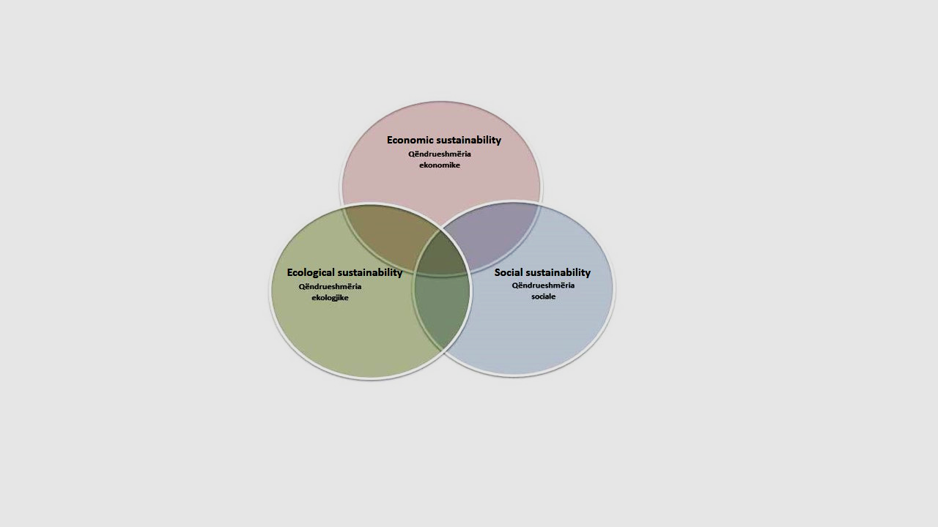

Figure 1*. Sustainable development scheme*

Sustainable development means qualitative growth and socio-economic and cultural development which is in relation to the capacities of the living environment which must be developed so that future generations are not hampered (endangered) by the possibilities of existence.

However, sustainable development can not be conceived only as activity which is oriented towards environmental protection and environmental problems (the first concepts for sustainable development) but is a multidimensional process of global character which includes social, economic, demographic, political issues, etc.

Agenda 2030 and Agenda 21 which have been transformed into: "global partnership for sustainable development" and "work program for the 21st century", underline the weight of demographic developments for sustainable development, therefore it is necessary: ​​the incorporation of demographic factors and trends in the analysis of sustainable development.

Having regard to the role and importance of demographic processes for sustainable development and the fact that the population is the biological structure of society and the economy of all geographical areas, it is necessary that for the sustainable development of contries, regions or municipalities in the first place to ensure demographic sustainability thus transforming demographic sustainability as a subsystem into the sustainability system.

*Also the specialized research institutions of the United Nations (United Nations Institute for Social Development - UNRISD and the United Nations Development Program - UNDP), demographic developments and their forecast rank (second) among the six main areas for completion of the objectives of Agenda 2030. The most important demographic components for completing the Agenda 2030 are: population growth trends, population trends by age, migration trends, urbanization trends and demographic projections****(1)****.*

1. **SUSTAINABLE DEMOGRAPHIC DEVELOPMENT - SUSTENDEMO**

At the center of sustainable development is undoubtedly the human-the population expressed also in the most important document of the contemporary concept of sustainable development which is the Rio Declaration 1992, respectively Agenda 21.

An important part (Chapter V) of Agenda 21 is devoted to the role and importance of demographic dynamics and its sustainability for sustainable development. For sustainable development in the future it is necessary that: demographic factors and trends be incorporated into the global analysis of environment and development;

Having regard to the role and importance of demographic movements for sustainable development and the fact that population is the biological structure of society and the economy of all geographical areas, demographic sustainability should be considered as a subsystem in the system of sustainability **(2)** - SUSTENDEMO.

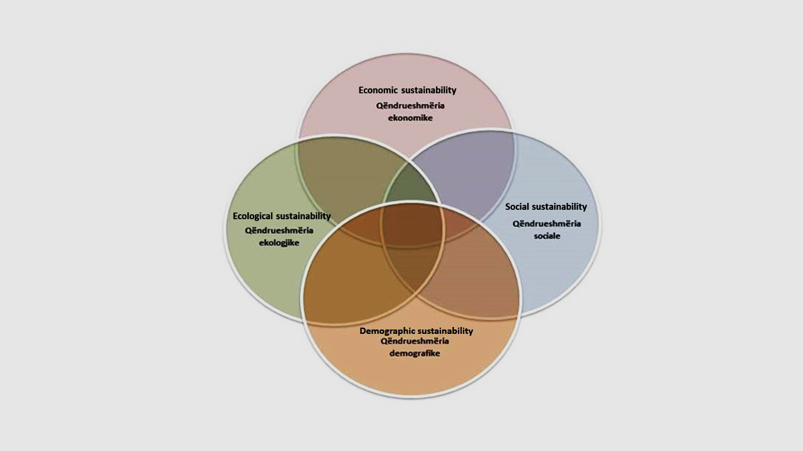

Figure 2*. Sustainable demographic development scheme - Sustendemo*

However, the sustainable demographic development is also often conceived in a very reduced way, only in population growth and the gender and age structure of the population. Based on this approach, different authors define sustainable demographic development with the state of the population which ensures at least simple reproduction of the population or "optimal population growth" which corresponds to the fertility level of 2.1 children per woman (reproduction with the same contingency as the previous generation). Other authors conceive of sustainable demographic development as a ratio between active (productive) and inactive (non-productive) population or even as a numerical balance in gender representation.

*The most comprehensive and complete definition is the definition of the authors who emphasize that the definition of sustainable demographic development should include the socio-economic characteristics of the population* ***(2)***.

Based on this definition the SUSTENDEMO model consists of two dimensions of equal importance which are the quantitative and the qualitative dimensions.

The quantitative dimension consists of components of natural growth and migration, overall population growth, and population structure by age and gender.

The qualitative dimension consists of the socio-economic characteristics of the population, including in the first place the educational structure of the population, professional training and economic activity.

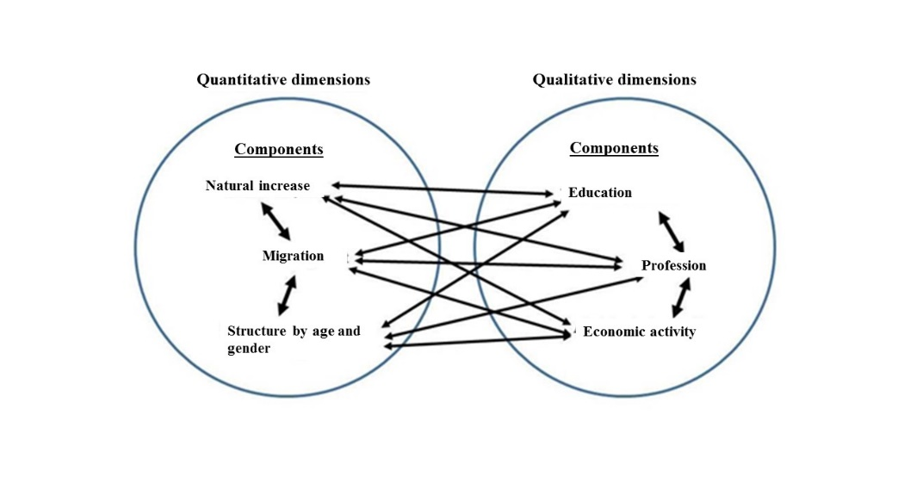

Figure 3. *Demographic sustainability subsystems* ***(3)***

*For sustainable demographic development of a certain area is required minimal demographic development (corresponding to at least simple reproduction - stationary type of population S.B) in quantitative and qualitative terms, in order to endure economic and social sustainability.*

*From the quantitative dimension a territory is considered demographically stable when there is an optimal correlation between: growth, size, migration and population structure by age and gender, while in qualitative terms a territory is considered demographically stable when there is a balance in socio-economic structures of the population* ***(3)****.*

Consequently, the United Nations forecasts of the end of the last century for the trends of the global population at the beginning of the 21st century have also been revised and corrected in all scenarios, as Bricker and Ibbitson point out. *"We are not facing the challenge of a population bomb, but of reducing the human population."* ***(4)***

1. **DEMOGRAPHIC PROCESSES AND SUSTAINABLE DEVELOPMENT**

**3.1 Are demographic changes the key to sustainable development**

People are the main concern of sustainable development (Rio Declaration, 1992, Principle 1). In an effort to promote sustainable development, demographic movements must also be taken into account) - number, location, age structure, other structures, especially education, living conditions, ambitions and opportunities, etc. (IIASA and UNFPA, 2011).

*The most comprehensive and complete definition is the definition: sustainable demographic development should also include the socio-economic characteristics of the population.*

The World Bank defines sustainable development as: *development which involves the transfer of an equal reserve or according to the greatest possibilities of human, economic and social capital, to future generations****(5)***.

Based on the above definitions, it can be concluded that for sustainable development of countries or regions, sustainable demographic development is necessary, which at least requires that each country should achieve a stationary population model, which means that the next generation will be the same as the existing one.

In order to achieve the necessary minimum and achieve demographic development which will not be limiting factors for sustainable development and fulfillment of the objectives of Agenda 2030, it is necessary to meet several objectives in demographic developments which are:

* 1. **Total number of population**

Total number of population - in order to achieve the stationary type of population where the next generation is the same as the existing one or the level of simple population regeneration or the replacement of generations means that at the individual level a woman in the period of her fertility should be replaced by a female child - the net reproduction rate is equal to one, or the overall fertility rate is 2.1 children per woman (reproduction with the same contingency as the previous generation).

* 1. **Population structure by age**

It shows not only the past but also the present and the future of demographic development and is the most important demographic indicator which in addition to population development also affects all other socio-economic spheres, therefore the analysis of population structure by age is basic. not only in demographic research but also for all other socio-economic spheres turning the process into an important factor for sustainable socio-economic and spatial development in general.

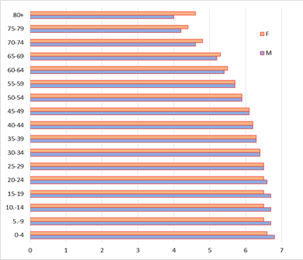

Figure 4. *Pyramid model of the population of stationary population type* ***(6).***

*A territory is considered demographically stable (in terms of population structure by age), when there is an optimal correlation in population structure by age and gender (graph 5).*

* 1. **Demographic ageing**

Agenda 2030 presents a universal action plan towards sustainable development in the protection and realization of the rights of all people without ignoring anyone and any group of society, including all segments of society, all ages, with a special focus on more vulnerable groups such as the elderly people.

The fact that the 21st century will be a century of ageing, the key to dealing with this process is the fact that the opportunities offered by these age groups will be used (incomparable experience and skills, active participation of older generations in the economy, labor market and society in general, etc.), to face the challenges posed by the process, to respond to the ageing of the population and to promote a sustainable development of ageing.

With the increase of the participation of the elderly in the general population of a country, the society should increase the knowledge about the importance, needs, rights of the elderly, with the purpose of eliminating prejudices and discrimination against the elderly.

In this way the main goal of the Agenda 2030 will be fulfilled through comprehensiveness and not bypassing anyone.

* 1. **Population migrations**

In the Agenda 2030 for Sustainable Development, migrations attract special attention in fulfilling this agenda and require interdisciplinary approach and multidimensional and comprehensive commitment in addressing the role and importance of migrations in order to fulfil the objectives of Agenda 2030.

Population migrations present significant potential to lift millions of people out of poverty by providing greater employment and access to decent jobs thus affecting sustainable development.

The close correlation that exists between development migration (both in the country of origin and the country of destination) and the weight of migration to achieve the SDOs make migrations an integral part of Agenda 2030 **(7)**.

In reality, migration is important for 8 of the 17 SDOs that show the role and importance of migration in fulfilment of the objectives of Agenda 2030. The agenda, specifically in Objective 10.7, requires: facilitation of migration, safe, orderly and accountable migration" implementation and good management of "migration policies"- sustainable migration model.

* 1. **Urbanization**

From the demographic point of view urbanism is understood as the process of concentration of population in cities (urban areas); from the urban point of view the issue is about the concentration of functions in a settlement; economists with urbanism imply the concentration of productive power in industry and post-industrial activities, whereas from the sociological point of view urbanism is a process of the level of social development which is accompanied by changes in the way of life.

The specialized organizations of the United Nations specify that the Agenda 2030 for Sustainable Development and its 17 objectives can only be successfully implemented and achieved if countries begin a transition towards sustainable urbanization. The necessity for sustainable urbanism derives from a demographic fact that until the end of the first half of the 21st century , over 65% of the world population will live in cities and towns.

Sustainable urban development is exclusively related to Objective 11 of the Agenda 2030.

In fact, sustainable urban development is essential for 11 of the 17 objectives of Agenda 2030.**(8)**

* 1. **Population projections**

*In the scope of the ways to promote sustainable development and fulfill the Agenda 2030, among the most important elements, according to UNFPA experts, is the integration of population projections in development strategies and policies* ***(9)***, emphasizing once again the role, importance and necessity of demographic developments for sustainable development.

Trends and perspectives on population growth, demographic ageing - population ageing, migration and urbanization represent the main opportunities and challenges of countries towards the Objectives for Sustainable Development and fulfillment of the Agenda 2030, with direct and indirect implications **(10)**.

**LITERATURE**

GLOBAL TRENDS, Challenges and Opportunities in the Implementation of the Sustainable Development Goals, © United Nations Development Programme and United Nations Research Institute for Social Development, 2017.

Lutz W.et al (2002), Population and environment, Population Council, New York, fq 6.

Roca Z, Roca M.N.O. Roca Z, Roca M.N.O. Demographic sustainability and spatial development in Portugal. Acta geographica Bosniae et Herzegovinae, 2014,2, p.25.fq.25.

Jadranka Polović: Demographic Challenges and the Future of Humanity ”., taken from: [https://www.geopolitika.news/analize/dr-sc- jadranka-polovic-demografski-izazovi-i-buducnost-covjecanstva /](https://www.geopolitika.news/analize/dr-sc-%20jadranka-polovic-demografski-izazovi-i-buducnost-covjecanstva%20/).

World Bank, Albania: The road to sustainable development., taken from; [www.bankofalbania.org/web/pub/sybi_hida_280_1.pdf](http://www.bankofalbania.org/web/pub/sybi_hida_280_1.pdf).

Behrami S. Bajraktari F, (2021) Demographic Dimension of Agenda 2030, the case of Kosovo- Perspectives and challenges. Institute for Development Policy. Prishtin.

Schraven, D. B., Keijzer, N., & Knoll, A. (2013). Post 2015: Making Migration Work for Sustainable Development .( Proucavanje Migracije Stanovnistva u Skladu sa Ciljevima Odrzivog Razvoja Ujedinjenih Nacija)

Sustainable urbanization strategy UNDP ’s support to sustainable, inclusive and resilient cities in the developing world, UNDP, New York, 2016, fq 6.. file:///C:/Users/sami/Downloads/UNDP_Urban-Strategy.pdf

Development, Co-operation Raport 2012. Lessons in Linking Sustainability and Development. http:// www.oecd ilibrary.org/docserver/download/4312011ec011.pdf?expires=1475241543&id=id&accname=guest&checksum=164431C2E94103DDF8FE25565CD9E189.

Population Dynamics in the Post-2015 Development Agenda: Report of the Global Thematic Consultation on Population Dynamics, UNFPA, UNDESA, UN-HABITAT, IOM 2013, Marr nga: <https://www.iom.int/files/live/sites/iom/files/What-We-Do/docs/Outcome-Report-Pop-dynamic-and-post-2015-dev-agenda-14-March-2013.pdf>