Demonstrational vegetable garden with ReSoil remediated soil

Domen Leštan  
 Envit Ltd. and University of Ljubljana

Ljubljana, Slovenia

domen.lestan@bf.uni-lj.si

ABSTRACT

Permission to make digital or hard copies of part or all of this work for personal or classroom use is granted without fee provided that copies are not made or distributed for profit or commercial advantage and that copies bear this notice and the full citation on the first page. Copyrights for third-party components of this work must be honored. For all other uses, contact the owner/author(s).

*Information Society 2020, 5–9 October 2020, Ljubljana, Slovenia*

© 2020 Copyright held by the owner/author(s).

The contaminated calcareous soil from Prevalje, Slovenia was EDTA-washed using novel ReSoil technology. Washing removed 71, 28 and 53% of soil Pb, Zn and Cd, respectively. The vegetable garden with 3 raised beds with non-remediated (original) and 6 beds with remediated soils was set up and realistically tended; a selection of 10 different produces were grown. All vegetables reached the mature phase without difficulties or visible deficiencies, irrespective of soil treatment. Grown on original soil all plants exceeded limits for Pb concentration in their edible parts stipulated by European Union legislature. In remediated soil only carrot exceeded limit for Pb. Remediation was less efficient in mitigation of Cd hazard; concentration of Cd in spinach, second cut of radicchio, and carrot exceeded the allowed values. The vegetable type is a strong determinant of metal concentration in edible crop. The selection of excluders instead of accumulators will thus be crucial for production of safe food on ReSoil remediated soils.

KEYWORDS

Soil, Toxic metals, Remediation, Vegetable garden

1. INTRODUCTION

Fertile soil is a valuable, limited resource. As human population and pressure on limited soil resources are continuously growing, more and more land contaminated with toxic metals is expected to be put under agricultural production in a delicate balance of needs, social & economic benefits and health risks. The harmful, pandemic effect of toxic metals on human health is well documented and governments are setting remediation of contaminated soil as a national priority.

We have recently introduced ReSoil soil washing technology which uses ethylenediamine-tetraacetate (EDTA) as a chelator [1, 2, 3]. The EDTA forms water-soluble complexes (chelates) with most toxic metals and is the most efficient chelator. The ReSoil was designed to recycle most of EDTA and all process water. For this to achieve the process solutions are treated by low-cost materials: lime, H2SO4, and wastepaper to impose pH gradient and induce recycling (substitution, precipitation and adsorption) reaction. The recycled EDTA and process water are reused in a closed loop, no wastewater is generated, and only solid waste enriched with toxic metals is produced. The EDTA is poorly biodegradable and persist in the environment. This has raised concerns about leaching of toxic chelates from remediated soil and risking groundwater contamination. In ReSoil extensive rinsing of remediated soil removes the majority of toxic chelates from the soil and zero-valent Fe (ZVI) is applied to the soil slurry to facilitate the permanent adsorption of the remaining chelates. We demonstrated that in ReSoil toxic emissions are not an issue [2, 4].

The aim of this study was to scale-up the ReSoil technology to provide enough soil to set-up and manage the genuine vegetable garden and to examine the possibility of production of safe food on remediated soil.

1. MATERIALS AND METHODS
   1. Soil Remediation

The surface soil was excavated from grassland in the bank of the river Meza in city of Prevalje in Meza Valley, Slovenia. The excavated soil was in situ homogenized and then transported to a nearby remediation facility for EDTA-soil washing using ReSoil technology.

* 1. Experimental garden

Raised beds (4 x 1 x 0.5 m) were constructed and vegetables: buckwheat, spinach, lamb’s lettuce, radicchio, garlic, onion, leek, lettuce, carrots and kohlrabi were grown in 6 rotations from the July 2018 until the end of November 2019.

* 1. Analysis

Samples of soil and vegetables were prepared as described before [4] and analyzed using graphite furnace AAS.

1. RESULTS AND DISCUSION

The novel remediation plant with ReSoil technology is depicted in **Figure 1**. The Technology Readiness Level of plant operation was TRL 7 (EU, NASA methodology). The permit for construction of ReSoil soil washing plant was granted by Slovenian Environmental Protection Agency in 2017, and the operating permit to remediate in July 2018. For this study the contaminated soil was remediated in series of 16 batchers – these were at the same time the first batches carried out in novel remediation plant. In total 16 tons of soil was washed.

Using EDTA in ReSoil technology decreased Pb, Zn and Cd soil concentration from 1854 ± 120, 3833 ± 135 and 21.2 ± 1.2 mg kg-1 to 545 ± 17, 2743 ± 120 and 9.9 ± 0.4 mg kg-1, respectively. To improve physical properties of remediated soil for vegetable production the buckwheat was sown as the first crop. Buckwheat is often used for green manuring. It has branched root system that reaches deep into the soil and improves soil aggregation through extensive network of fine roots.

The future of ReSoil, as of any other technological eco-innovation, relies on its social acceptance. Local population was therefore invited to select the final assortment of produces. All plants grown on original and remediated soil reached the mature phase without difficulties or visible deficiencies. We observed no statistically significant differences in plant biomass, and no chlorosis indicating lack of micronutrients (Figure 2).

The metal plant uptake is known to vary strongly across plant species and growing stages. Soil washing with ReSoil the most consistently prevented accumulation of Pb in edible parts of vegetables. The Pb uptake was reduced from 76% in garlic to 95% in kohlrabi. The uptake of essential element Zn was distributed more uniformly, with differences of only 14% between lettuce grown remediated and original soil, and the highest reduction of 76% in the first cut of radicchio. Cadmium (and Pb) is believed to be non-essential element. Nevertheless, plants often adsorb Cd instead of Zn, which is biologically antagonistic micronutrients with similar ionic radius. The smallest difference in Cd uptake, 33%, was measured in roots of carrots grown on remediated soils, the highest reduction, 90.8 and 91.4% was in the second cut of radicchio and leek.

The European Union has defined maximum levels of Pb and Cd to be found in vegetables. To facilitate comparison with EU guidance values the vegetable samples were analyzed for toxic metals also on a fresh weight basis (Figure 3). Grown on original soil all vegetables exceeded stipulated limits for Pb concentration in their edible parts. In remediated soil only carrot exceeded limit for Pb. Remediation was less efficient in mitigation of Cd hazard; concentration of Cd in spinach, second cut of radicchio, and carrot exceeded the allowed values. In accordance to our results spinach and carrots are often identified as the major Cd accumulators. Substantial genotypic variation, however, exists among species and cultivars [5]. For example Kugonič et al. [6] reported that carrot grown in Zasavje region in Slovenia in unpolluted calcareous soil (similar to soil used in our study) with Cd concentration ranging from 0.13 - 0.69 mg kg-1 accumulated 0.3 - 0.8 mg kg-1 of Cd in roots, which is higher than stipulated by EU, and higher than in carrot grown on remediated soils in our study.

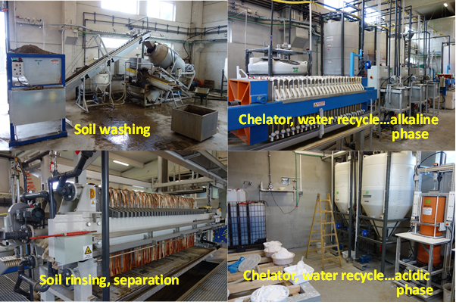

Figure 1: Demonstrational soil-washing plant (TRL 7) with ReSoil technology in the city of Prevalje, Slovenia. The plant with capacity of 1.5 tons of soil per batch is operated by Envit Ltd. The plant construction was supported by the EU project LIFE12 ENV/SI/000969 (<http://www.envit.si/>).

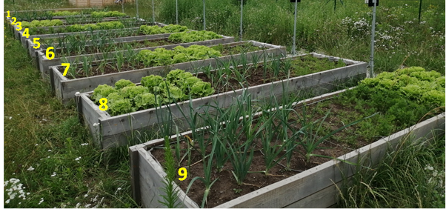

Figure 2: Vegetable garden with remediated (raised beds 2, 4, 5, 7, 8, 9) and original (beds 1, 3, 6) soil. The growth of leek, lettuce and carrots (4. Rotation, Maj 20, 2019) is depicted.

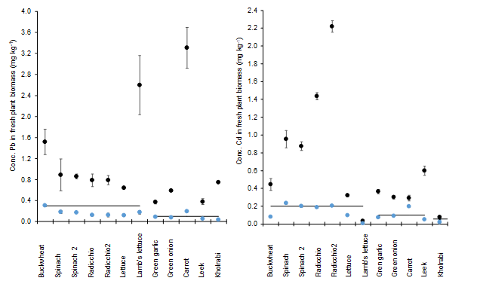

Figure 2: Concentration of Pb and Cd in edible parts of vegetables (wet biomass) grown on original soil (black circles) and remediated soil (blue circles). Horizontal lines depict maximum permissible levels of Pb and Cd in vegetables as stipulated by European Union legislature. Data are given as average of 3 samples with standard error.

ACKNOWLEDGMENTS

This work was supported by the EU project LIFE12 ENV/SI/000969 and by the Slovenian Research Agency under Grants J4-8219 and P4-0085.

REFERENCES

1. Lestan, D., 2017. Novel chelant-based washing method for soil contaminated with Pb and other metals: A pilot-scale study. L. Degrad. Dev. 28, 2585-2595.
2. Lestan, D., 2019. Curbing toxic emissions from remediated substrate. EP 3 492 187 A1
3. Lestan, D., Finzgar, N., Gerl, M., Gluhar, S., Lakovic, G., Hamiti, B., 2018. Method for soil and sediment remediation. EP 3 153 246 B1.
4. Gluhar, S., Jež, E., Lestan, D., 2019. The use of zero-valent Fe for curbing toxic emissions after EDTA-based washing of Pb, Zn and Cd contaminated calcareous and acidic soil. Chemosphere. 215,
5. Yang, J., Guo, H., Ma, Y., Wang, L., Wei, D., Hua, L., 2010: Genotypic variations in the accumulation of Cd exhibited by different vegetables. J. Environ. Sci., 22, 1246–1252.
6. Kugonič, N., Grčman H., 1999. The Accumulation of Cadmium, Lead and Zinc by different Vegetables from Zasavje (Slovenia). Phyton (Austria). Phyton 39, 161-165.