**Machine Vision System for Quality Control in Manufacturing Lines**

Ivana Kiprijanovska   
 Department of Intelligent Systems  
 Jožef Stefan Institute,

Jožef Stefan International Postgraduate School,

Ljubljana, Slovenia ivana.kiprijanovska@ijs.si

Jani Bizjak  
 Department of Intelligent Systems  
Jožef Stefan Institute,

Jožef Stefan International Postgraduate School  
 Ljubljana, Slovenia  
 [jani.bizjak@ijs.si](mailto:jani.bizjak@ijs.si)

Samo Gazvoda

Cooking Appliances

Division

Gorenje Group

samo.gazvoda@gorenje.com

Matjaž Gams  
 Department of Intelligent Systems  
Jožef Stefan Institute,

Jožef Stefan International Postgraduate School  
 Ljubljana, Slovenia  
 [matjaz.gams@ijs.si](mailto:matjaz.gams@ijs.si)

ABSTRACT

Permission to make digital or hard copies of part or all of this work for personal or classroom use is granted without fee provided that copies are not made or distributed for profit or commercial advantage and that copies bear this notice and the full citation on the first page. Copyrights for third-party components of this work must be honored. For all other uses, contact the owner/author(s).

*Information Society 2020, 5–9 October, 2020, Ljubljana, Slovenia*

© 2020 Copyright held by the owner/author(s).

In manufacturing, quality control is a process that oversees the aspects of production and ensures that only products that conform to industry standards and quality criteria leave the production line. Automation of the quality control process significantly reduces the time spent on products’ testing, hence reducing the overall manufacturing costs. In this paper, we present a brief overview of the algorithms adopted to the aim of detection of one possible fault in the production of ovens – non-working oven fan. The detection is performed through visual data. In the initial experiments, several image processing algorithms were used, and the preliminary results are encouraging.

KEYWORDS

machine vision, image processing, fault detection

1. INTRODUCTION

Quality control is becoming an increasingly important aspect of today’s manufacturing processes [1]. For efficient and successful production, manufacturers rely on quality control systems integrated into the manufacturing process. The traditional quality control process requires vast capacities of specialized labor. High utilization of the specialists may lead to human errors, low reliability of the process, and a negative impact on the quality of production. Compared to manual quality control, automated quality control systems offer a reliable control process with various other advantages, including the ability to work 24 hours a day and, in some tasks, perform faster measurements with higher accuracy and consistency compared to humans [2]. Such systems are also a practical choice when the test cases need to run regularly over a significant amount of time. Machine vision quality control systems play a growing role in modern manufacturing quality control systems. These systems rely on digital sensors inside

industrial cameras with specialized optics to acquire images [3]. After an image is acquired, computer hardware and software process, analyze, and measure various characteristics of the image for automated decision-making.

Development of an integrated system for comprehensive quality control in production with an intelligent process control system is the main aim of the ROBKONCEL project [4]. One of the objectives of this project is the detection of faults in the production of ovens. In this paper, we present the initial experiments in the detection of one of the possible faults – non-working oven fan.

1. PROBLEM DEFINITION

The quality control of the ovens is intended to take place in a factory environment, where products moving on a conveyor belt are visually observed, i.e., a machine vision system acquires videos of the ovens. These videos are segmented into image frames (at a 30 fps rate), and the obtained image frames are further processed to detect if the fan is working or not. For the initial experiments, we collected a few videos in a laboratory setting, with various lightings and camera positions, resulting in approximately 7200 images (~4000 working fan and ~3200 non-working fan). Additionally, the visual data of the ovens’ fans were acquired through a closed door, which makes the fault detection more challenging (Figure 1). This is preferred as the process of opening and closing the door in a manufacturing environment would be too slow.

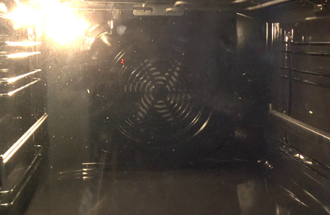

Figure 1: Image of an oven's fan acquired through a closed oven door.

1. IMPLEMENTED TECHNIQUES

The image processing steps for the oven fault detection, i.e., non-working fan detection, are as following:

1. Object detection
2. Glare reduction
3. Image thresholding

Each of these steps and the image processing algorithms implemented in them are explained in the following sections.

* 1. Object detection

In order to detect and isolate the circle area of the oven fan, we made use of the Hough Gradient Method [5], which is an extension to the standard Hough Transform technique [6] for isolating features of a particular shape within an image. The Hough Gradient Method is based on gradient information of edges and is used to improve the speed of the circle detection in order to meet real-time implementation requirements. The calculation steps of the Hough Gradient method are as follows: (i) detect edges in the image; (ii) calculate the local gradient for the edge points using a Sobel operator; (iii) use an accumulator to count the possible circle center on the normal direction of edge points’ tangent; (iv) choose the peak circle center and circle radius for the general circle equation.

The implementation of the Hough Gradient method in OpenCV requires a single channel image, so the first step in the detection of circles was to convert the acquired images from the RGB color space to grayscale. Furthermore, two parameters of the circle detection function were tuned, namely: the minimum distance between the center coordinates of the detected circles and the ratio of the resolution of the original image to the accumulator resolution [5]. Before running the circle detection function, a simple median filter [7] was applied to the images for noise reduction. This helped in reducing the effects of various reflections in the glass part of the oven door. In general, without blurring, the algorithm tended to extract too many circular features, resulting in false circles detection. Therefore, this preprocessing step was crucial for successful circle detection. The circled detection algorithm resulted in a single circle detected in every image; however, with a varying radius. Since the further analyses require images with the same dimensions, the mean value of the detected circles’ radius was calculated and used to isolate the fan area on the images. (Figure 2).

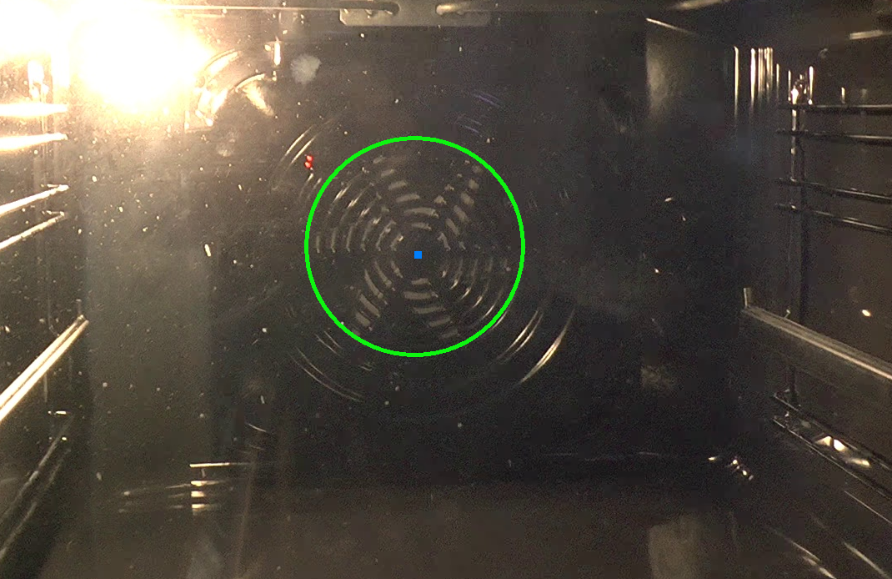

Figure 2: Detected oven's fan area.

* 1. Glare reduction

A common problem in image processing is the occurrence of specular reflections on the images. In our case, since the videos of the fan were recorded through a glass, a significant amount of specular reflections, or glare, was produced during the recording. To reduce the effects of the glare, a glare reduction algorithm was applied. The basic glare reduction procedure consisted of 3 steps: (i) decomposition of the original image into a color, saturation and brightness component (HSV); (ii) finding particularly bright areas in the image; (iii) inpainting of these areas with the values of the surrounding pixels.

Each image was first converted into HSV color space, which describes the image by its hue (H), saturation (S) and brightness (V) component (Figure 3).

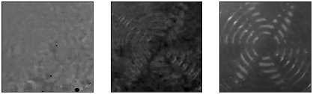

Figure 3: Image decomposition into hue, saturation and brightness component.

With such decomposition, a general rule for pixels that are subject to specular reflections can be derived; namely, an image can only contain glare if its color is not saturated, and it has high brightness. Since light reflections are white, any pixel containing glare cannot have saturation (since white has no color or saturation). Accordingly, we first filtered out the areas that have low saturation. Next, the area of the non-saturated pixel was reduced by an erosion operation, and the brightness values of the saturated pixels were set to 0. By filtering out the very bright pixels (e.g., all pixels that have a value larger than 130), we obtained the final glare mask (Figure 4).

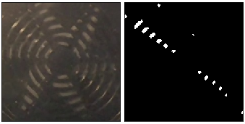

Figure 4: Original image and the obtained glare mask.

The glared pixels were then interpolated with an inpainting operation. This operation fills the masked pixels with the values that stem from the adjacent non-masked pixels. The original image and its corrected version after the reduction of the glare can be seen in Figure 5. There is a significant amount of glare on the original image, which was effectively removed in the corrected image. The corrected image is a good approximation of the original image when no glare is present.

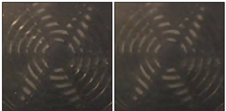

Figure 5: Original image and its corrected version.

* 1. Thresholding

If the two figures representing working and non-working fan in Figure 6 are analyzed, it can be seen that lighting allows the oven fan parts to stand out and be clearly seen behind the grid when the fan is not working. On the other hand, when the fan is working, the fan area behind the grid is blurred. Therefore, a simple thresholding method was utilized to distinguish working and non-working fan.

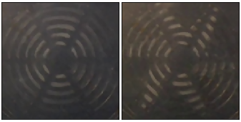

Figure 6: Working and non-working oven fan.

Thresholding is one of the simplest methods for image segmentation and creation of binary images [6]. The main goal of the utilized binary thresholding was to enhance the parts of the oven fan when it is not working. For that purpose, the images were firstly converted from RGB color space to grayscale. Next, with the binary thresholding method, each pixel in the images was replaced with a black pixel if its intensity was less than a chosen constant (T=90), or a white pixel if its intensity was greater than the chosen constant. This results in the illuminated parts of the oven fan becoming completely white (when the fan is not working), while the grid and the moving fan become completely black, as can be seen in the examples in Figure 7.

As a final step, the number of white pixels in the final binary-threshold images, which present only the non-working fans, was calculated. Then, the 5th percentile of these values was calculated and set as a threshold value when deciding if a given image represents a working or non-working fan. Basically, if the image contains more than X white pixels, where X is the previously calculated value of the 5th percentile, it is classified as a non-working oven fan; otherwise, it is classified as a working oven fan.

In the last post-processing step, the class for each image frame was taken as the majority class of the last 20 frames. It helped in eliminating quick 1-frame changes from working to non-working, or vice versa.

Eventually, the implemented image-processing method resulted in 95% of correctly classified images, on four different videos. The confusion matrix of the method is presented in Table 1.

Table : Confusion matrix for the proposed method.

|  |  |  |
| --- | --- | --- |
|  | Non-working | Working |
| Non-working | 3117 | 82 |
| Working | 280 | 3720 |

As the main purpose of the system is to offer a high accuracy in detection of oven faults, while filtering false alarms, we additionally analysed two metrics: (i) sensitivity, i.e., method’s capacity to detect actual faults (non-working fans), defined as the ratio between the number of non-working fan images correctly identified (true positives) and the total number of non-working fan images; (ii) specificity, i.e., method’s capacity to filter false alarms, defined as the ratio between properly discarded images (true negatives) and the total number of discarded images. The method has a very high sensitivity score of 97%, and specificity score of 93%.



Figure 7: Non-working and working oven fan – thresholded images

1. CONCLUSION

In this paper, we presented an image processing pipeline adopted for the aim of detection of a possible fault in production of ovens – non-working oven fan. The image processing steps contain object detection (for isolating the oven fan area from the images), glare reduction (for reducing the effects of specular reflections), and image thresholding (for final decision-making). The preliminary results show that a quality control system that exploits image processing algorithms could be used in an automated manufacturing environment. In the future, we plan to employ reflection removal algorithms, which can significantly facilitate the object detection process, such as Sparse Blind Separation with Motions (SPBS-M) [8], Superimposed Image Decomposition (SID) [9], Ghosting Cues [10] and similar. However, the utilization of such algorithms may significantly impact the time performance of the method, so an acceptable trade-off between method’s accuracy and time performance should be explored in future analyses.

ACKNOWLEDGMENTS

The first author acknowledges the financial support from the Slovene Human Resources Development and Scholarship Fund – Ad Futura. Part of this research was done under and for ROBKONCEL project.

REFERENCES

1. Mohamad, H.; Jenal, R.; Genas, D. Quality Control Implementation in Manufacturing Companies: Motivating Factors and Challenges. In Applications and Experiences of Quality Control; 2011.
2. Heleno, P.; Davies, R.; Brazio Correia, B.A.; Dinis, J. A machine vision quality control system for industrial acrylic fibre production. EURASIP J. Appl. Signal Processing 2002.
3. Golnabi, H.; Asadpour, A. Design and application of industrial machine vision systems. Robot. Comput. Integr. Manuf. 2007.
4. ROBKONCEL Available online: http://www.smm.si/?post_id=4682&lang=en (accessed on Aug 28, 2020).
5. Yuen, H.K.; Princen, J.; Dlingworth, J.; Kittler, J. A Comparative Study of Hough Transform Methods for Circle Finding.; 2013.
6. Shapiro, L.; Stockman, G. Computer Vision 1st Edition; 2001; ISBN 9780130307965.
7. Huang, T.S.; Yang, G.J.; Tang, G.Y. A Fast Two-Dimensional Median Filtering Algorithm. IEEE Trans. Acoust. 1979.
8. Gai, K.; Shi, Z.; Zhang, C. Blind separation of superimposed moving images using image statistics. IEEE Trans. Pattern Anal. Mach. Intell. 2012.
9. Guo, X.; Cao, X.; Ma, Y. Robust separation of reflection from multiple images. In Proceedings of the Proceedings of the IEEE Computer Society Conference on Computer Vision and Pattern Recognition; 2014.
10. Shih, Y.; Krishnan, D.; Durand, F.; Freeman, W.T. Reflection removal using ghosting cues. In Proceedings of the Proceedings of the IEEE Computer Society Conference on Computer Vision and Pattern Recognition; 2015.