Etika v raziskavah, primer JRC "TTO Circle" organizacij; Ethics in research issues, an example of JRC "TTO Circle" organizations

dr. Špela Stres

Jožef Stefan Institute, Center for Innovation and Technology Transfer

+386 1 477 3200

[spela.stres@ijs.si](mailto:spela.stres@ijs.si)

**ABSTRACT**

In this paper, we describe the use of ethics principles in research matters in the organizations, which form part of the Joint Research Center’s TTO Circle ([1]).

**Keywords**

Ethics, principles, survey, TTO Circle, JRC

# INTRODUCTION

As a part of the H2020 funded NewHorrizon project on responsible research and innovation we were investigating the question of the importance of non-regulatory / non-conventional ethics and research integrity issues in European Public Research Organizations to look beyond standard ethics regulatory issues and processes.

This work is based on previously developed situational analysis questionnaires for analysis of ethics principles in research matters in the research organizations, presented in our article “Ethics in research issues: development of a situational analysis questionnaire”.

We carried out a short survey about the perception of ethical behavior in different situations within public research organizations from researcher’s personal and institutional point of view.

# PREPARATION OF THE SURVEY

The ethics issues we were interested in, went beyond the conventional ethical issues (as integrity, responsibility, honesty, competence) [3 General research on ethics] or more philosophical ones (dignity, non-maleficence) [4 JRC handbook] and strived away from the IPR issues (privacy, confidentiality, justice) [5 WIPO Handbook]. Also, the issues we set to analyze, were broader, but due to addressing specific situations also more concrete than the ones included in the [6 Consensus statement].

The survey took place among the members of the TTO Circle, which currently are 31. This is a finite amount of data, but highly prominent at the same time, as high-level officials of Public Research Organizations are involved in the TTO Circle operations ([1]).

The TTO Circle stands for the European Technology Transfer Offices circle. This is a network of research institutions, established with the aim to bring together the major public research organizations in order to share best practices, knowledge and expertise, perform joint activities and develop a common approach towards international standards for the professionalization of technology transfer.

The European TTO circle gathers the largest public research organizations across Europe. The network comprises currently 31 organizations (198349 scientific staff, 5243 softwares, 34338 patents and 4143 start-ups). The partners signed a Memorandum of Understanding formalizing their collaboration. They agreed to strengthen Europe's ability to create innovative products and services for the market. ([2]).

Jožef Stefan Institute has become a member of the TTO Circle in 2016. During the 2018 and 2019 a survey and an analysis of research ethics attitudes and behaviors has been carried out to understand the level of inclusivity for ethics and ethical assessments within the situations that arise in research operations.

# EXECUTION OF THE SURVEY

A separate platform has been built to allow only single responses from specific institutions. It made available the basic information and rights of the respondent at any time and collected responses that could be reviewed but not changed after submission.

A developed situational analysis questionnaire has been uploaded to the platform and the link sent to the selected representatives of the member public research organizations of the TTO Circle.

The questionnaires were answered by the selected representatives. We collected 22 filled out questionnaires out of the 31 institutions. The TTO Circle organizations are a representative sample of the highest level of the European research attitudes. An almost 71% response rate confirms a high involvement of these organizations with the ethical issues.

The research organizations interviewed engage in different fields of research work (Fig.1), but the majority of them is involved in research and development also in the IT field (85% engineering sciences, 10% language, information and communication, 60% digitalization, ICT, big data).

These organizations are closely related to the issues of ethics of IT specialists and other specialists working in the research field and is crucial for the relation of science or facts to the truth as accepted by the general society.

However, there is also a wider question to be answered, namely, is the scientific and research operation itself immune to ethical issues?

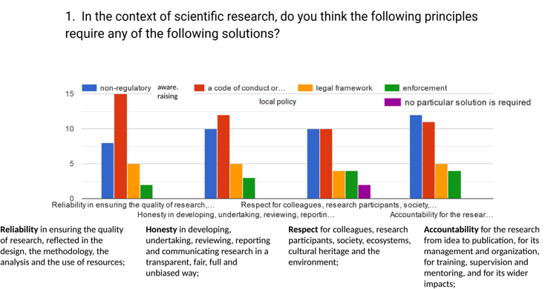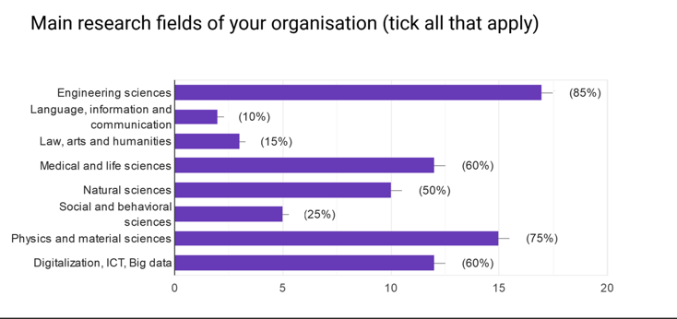

Figure 1: The distribution of research fields of the interviewed research organizations.

And how are particular situations, principles, themes addressed when faced in the research community, either from a personal point of view of a certain researcher or from the point of view of the whole organization?

# RESULTS

## The personal attitudes

The **necessity to involve ethical assessments in any of the four principles (reliability, respect, honesty and accountability)** was analyzed within the first set of questions.

The analysis showed that “reliability in ensuring the quality of research reflected in the design, the methodology, the analysis and the use of resources”, is the most unifying principle among the four. More than 68% of respondents believe a code of conduct or a local policy should be set in place to assure reliability in research quality.

On the other hand, the only principle that evoked a response “no practical solution is required”, even if in only 9% of respondents, was “respect for colleagues, research participants, society, ecosystems, cultural heritage and the environment”. This can be understood as a proof that the respect for all involved in the research actions is either already very high (and thus no particular solution is required) or the situation is in the minds of the researchers to be left unaddressed (best as it is and as left to the research autonomy). Mind that 45% of respondents think that non-regulatory and 45% of respondents think that a code of conduct or local policy would be needed to address the issues of mutual respect in the research society.

The latter (non-regulatory, awareness raising or a code of conduct and local policy were also by far the most popular answers in all four principles in question (reliability, honesty, respect and accountability). As opposed to more than 77% of respondents asking for non-regulatory, awareness raising, code of conduct or local policy actions, the legal framework would be used by 21% of respondents on average and enforcement by only 14% of respondents (see Fig.2).

The **personal level of necessity to establish ethical assessment in some particular common research situations** was evaluated within the second set of questions. There were some situations that clearly showed preference of the respondents towards execution of ethical assessments: research involving animals 95%, research involving children 91%, STEM cells research 86%, activities that result in personal financial benefit for the researcher 86%, research involving adults 82%, asking a new student to do measurements and using these measurements in a paper without credit 82%.

There were situations that clearly showed the opposite preference – that the ethical assessment would be not needed: scheduling meetings outside the core working hours (77% thought this is not an issue in need of ethical assessment); and 73% thought that organizing conferences that require travel at weekends is not problematic either. It would be important to observe the distribution of answers here in terms of female and male respondents, but we do not have this data available.

Figure 2: The solutions needed to assure the four basic principles in the context of scientific research.

There was a set of situations where a slight majority would require an ethical assessment: researching new topics without broad social agreement through a consultation on consequences 57%; the process that senior authors decide who is included in the author list of a publication and the process that the senior authors decide the order of the author list, both 55%; formation of an interview board for hiring processes 53%.

There was also a set of situations where a slight majority was against having the ethical assessments: using an ICT tool for internal submission seen by everyone so anyone can request authorship with 59% against and accepting invitations to panels that did not make a demonstrated effort in gender equality 55% against any ethical assessment needed.

The analysis showed a clear bias of the researchers towards already established procedures (which were named as necessary to be in ethical assessment), but less prevalent were topics that affect everyday life (work-life balance) and topics that are as of yet not part of the regulatory system (agreement with the cultural and social environment about the research topics).

Having understood these personal points of view we then also tried to analyze the organizational attitudes and set-ups.

## The organizational attitudes

As expected, the organizational attitude has proven to be a more difficult issue than the personal attitude of the respondents, as on the average within the set of 16 questions almost 18% of respondents declared that they are not sure of what type the consideration of ethical issues within their organization is.

On the other hand there were some settings that clearly showed institutional orientation towards ethical assessment: for recruitment 83% of those who knew the institutional orientation regarded this setting as one that is covered by ethical assessment in their organization, 65% of institutions considered there to be necessity for ethical assessment for announcement of positions and 70% of institutions considered there to be ethical aspects and take them into account in terms of members of governing bodies and their operations with 56% considered there to be ethical aspects and take them into account in their advisory boards.

There were also some settings that clearly showed reluctance to involve any ethical aspect consideration: letters of recommendation 78% of the ones who knew the organizational position claimed their organizations do not consider there to be ethical aspects and do not take them into account; 75% for project invitations and 70% for operations of editorial boards; CV preparation (73%), speaking events (73%), but also (impressively) 64% for internal faculty funding allocation and for memberships.

For some settings the balance was slightly positive (prizes/award committees with 58% in favor of ethical assessments) and for some it was slightly negative (performance reviews 64%, visibility 60%, choosing research topics 58% for rejecting the ethical assessments).

The distribution of institutional orientations shows that the institutions try to address first the situations, connected to ethical aspects, that are also connected to financial and research position benefits, whereas every day research and research work aspects are currently being less considered.

If we wanted to **consider the forms in which the organizations take ethical issues into account**, we found out that the majority of organizations relies on awareness raising via listing of the expectations from the community to address the ethical issues (72%) and on formal guidelines (76%).

Less formalized option of informal guidelines 66%) and a more formal option of the code of conduct or local policy (57%) together with an ethical review committee (53%) were also used. More than 62% of organizations also have a procedural document (in terms of policy) to address the ethical issues and take them into account. The least used tools are field and context dependent ethical committees (76% do not use them) and legal framework in terms of national legislation (53% do not have it).

Surprisingly, 83% of the respondents stated that it is not true that their organizations would not take ethical issues into account in the described settings, namely that only 17% of the respondents are employed in institutions that would not be aware of the importance of ethical issues and ethical assessments in the described settings.

The analysis of forms in which the organizations take ethical issues into account shows that the organizational level of ethical responsibility is higher than the personal one, which could lead to improvements in ethical assessments of particular settings in the future years.

We also investigated **the type of input that the respondents think should be available from their organizations** in particular settings where ethical assessment might be necessary.

In project invitations, visibility, prizes/awards and committees the prevailing requested input from the research organizations to the side of research community would be awareness raising. Whereas in performance reviews the community would require formal guidelines and in project coordination a code of conduct. (and also, awareness raising of the same level). Surprisingly, in CV preparation there is an equal request for awareness raising and for legal framework in terms of national legislation.

Governing bodies should have formal guidelines in ethical aspects of their operation and in recruitment, speaking events and internal faculty funding a strong majority requires procedural documents in terms of a policy, closely followed by a request for formal guidelines.

Surprisingly, in many situations the research community requests their research organizations to impose a more transparent rule set in a more organized, more formal and more systematic way.

This shows that even though the organizations do take ethical issues into account and are leading the way to a more relaxed personal point of view of a particular researcher, there are improvements to be made in the way how organized and transparent are the processes of imposing these onto the research community.

# CONCLUSIONS

The analysis showed a clear bias of the researchers towards already established procedures (those were named as necessary to be in ethical assessment), but less prevalent were topics that affect everyday life (work-life balance, agreement with the cultural and social environment about the research topics).

The distribution of institutional orientations showed that the institutions try to address first the situations, connected to ethical aspects, that are also connected to financial and research position benefits, whereas every day research and research work aspects are currently being less considered.

The analysis of forms in which the organizations take ethical issues into account showed that the organizational level of ethical responsibility is higher than the personal one, which could lead to improvements in ethical assessments of particular settings in the future years.

The type of input that the respondents think should be available from their organizations in many situations where ethical assessments might be necessary, shows that the research community requests their research organizations to impose a more transparent rule set in a more organized and systematic way. This showed that even though the organizations do take ethical issues into account, there are improvements to be made in the way how organized and transparent are the processes of imposing these onto the research community.

# REFERENCES

1. JRC TTO Circle Publication, 18.8.2019, <https://ec.europa.eu/jrc/communities/en/community/tto-circle-community>.
2. JRC TTO Circle Publication, 18.8.2019, <https://ec.europa.eu/jrc/communities/en/community/european-tto-circle/page/tto-circles-members>
3. Eric Breit et all.. 2016. Promoting Integrity as an Integral Dimension of Excellence in Research. EU project No. 665926 report.
4. Boucher Philip et al.. Ethics dialogues. Experiencing Ethics through ‘things’. 2014. ISBN 978-92-79-45049-5
5. WIPO. 2017. Successful Technology Licensing. Publication No. 903E 2015 Edition ISBN 978-92-805-2633-2
6. Ellen‑Marie Forsberg et al. 2018. EUROPEAN CONSENSUS STATEMENT. Sci Eng Ethics, 24:1023–1034. Working with Research Integrity — Guidance for Research Performing Organizations: The Bonn PRINTEGER Statement.