Etika v raziskavah: razvoj vprašalnika za situacijsko analizo

Ethics in research issues: development of a situational analysis questionnaire

dr. Špela Stres

Jožef Stefan Institute, Center for Innovation and Technology Transfer

+386 1 477 3200

[spela.stres@ijs.si](mailto:spela.stres@ijs.si)

**ABSTRACT**

In this paper, we describe the development of a questionnaire to be used in situational analysis of ethics principles in research matters in the organizations.

**Keywords**

Ethics, principles, survey

# INTRODUCTION

As a part of the H2020 funded NewHorrizon project on responsible research and innovation we were investigating the question of the importance of non-regulatory / non-conventional ethics and research integrity issues in European Public Research Organizations to look beyond standard ethics regulatory issues and processes.

In our everyday life of a Center for Innovation and Technology Transfer we meet many researchers. Whenever we ask them a question: “What do you think about ethics in research?”, we get a specific answer. The answer is: “----“(silence and a perplexed look in their eyes).

Thus, we decided to develop a research tool to analyze the perception of ethical behavior in different situations within public research organizations from researcher’s personal and institutional point of view.

# PREPARATION OF THE SURVEY

## The motivation

The ethics issues we were interested in, went beyond the conventional ethical issues (as integrity, responsibility, honesty, competence) [3 General research on ethics] or more philosophical ones (dignity, non-maleficence) [4 JRC handbook] and strived away from the IPR issues (privacy, confidentiality, justice) [5 WIPO Handbook].

Also, the issues we set to analyze, were broader, but due to addressing specific situations also more concrete than the ones included in the [6 Consensus statement]. Even though this document emphasizes that the responsibility for ethical research lies with everyone who is active in research, but especially with leaders in research performing organizations, it remains open that the researchers’ morals alone cannot ensure research integrity; good conditions for exercising integrity must also be created at the level of the organization and the research system. Also, in short-term, project-based positions, the role of the project leader in instilling ethical standards are crucial, as staff on shorter contracts are often not integrated in the organization to the same extent as permanent staff.

Having considered this, our analysis was based on a specific set of situations that were described as potentially ethically problematic by a group of scientists from three different countries, Sweden, UK and Slovenia. In the mentioned group Sweden represented the Nordic approach, UK the central European one and Slovenia the Balkan region approach to the ethical issues. The chosen group selected the initial set of situations to be surveyed and analyzed within the TTO Circle. The situations were modeled by JSI and the questions were developed at JSI.

# RESULTS: THE QUESTIONNAIRE

## The general motivation part

There were five main sets of questions in the questionnaire.

**The first set of questions** focused on the principles in the context of scientific research that would or would not require any of the solutions, focused on improving the ethics and ethical attitudes in those situations. An example of the questionnaire matrices is given below in Figures 2-5.

The general principles focused on topics as reliability in ensuring the quality of research, the honesty in developing and undertaking, reviewing, reporting research; the Respect for colleagues, participants, society; and the Accountability for the research from idea to publication, for its management and organization.

The main idea was to distinguish between different principles that should all be equally underlying in the research work.

There were four (4) principles and five (5) different categories offered with different levels of formalization, ranging from non-regulatory, through a code of conduct or a local policy, through legal framework in place and to on the spot enforcement. Also, the option of “no particular solution is required” was offered to enable those, who believe researchers need to be individualistic and of free will with no external boundaries also when ethical behavior is 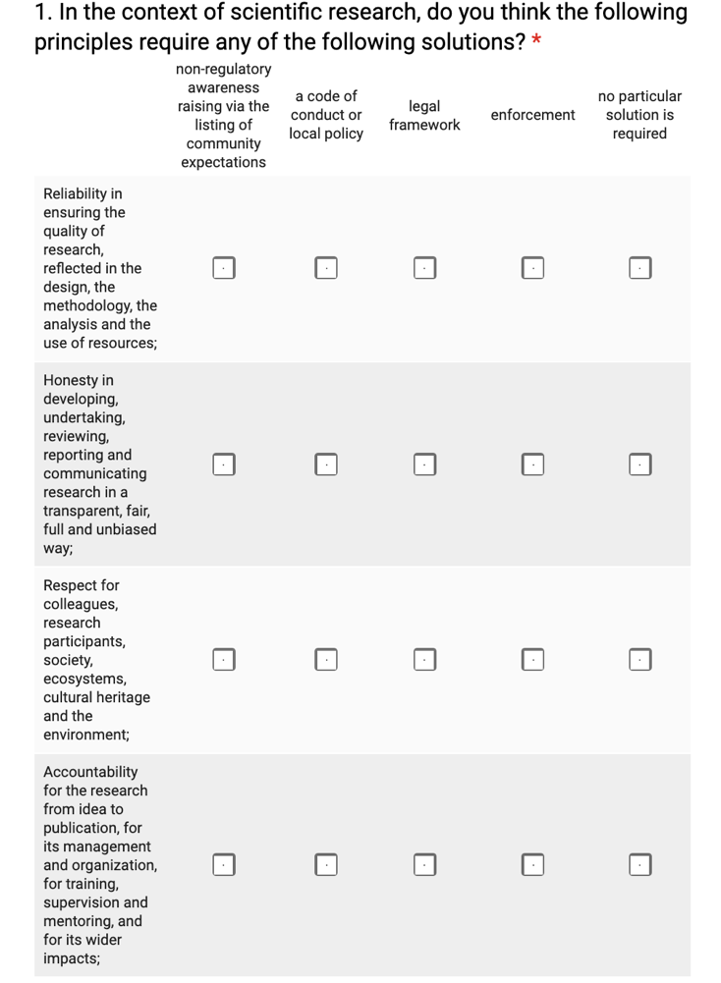considered, to share their opinion (see Fig 1).

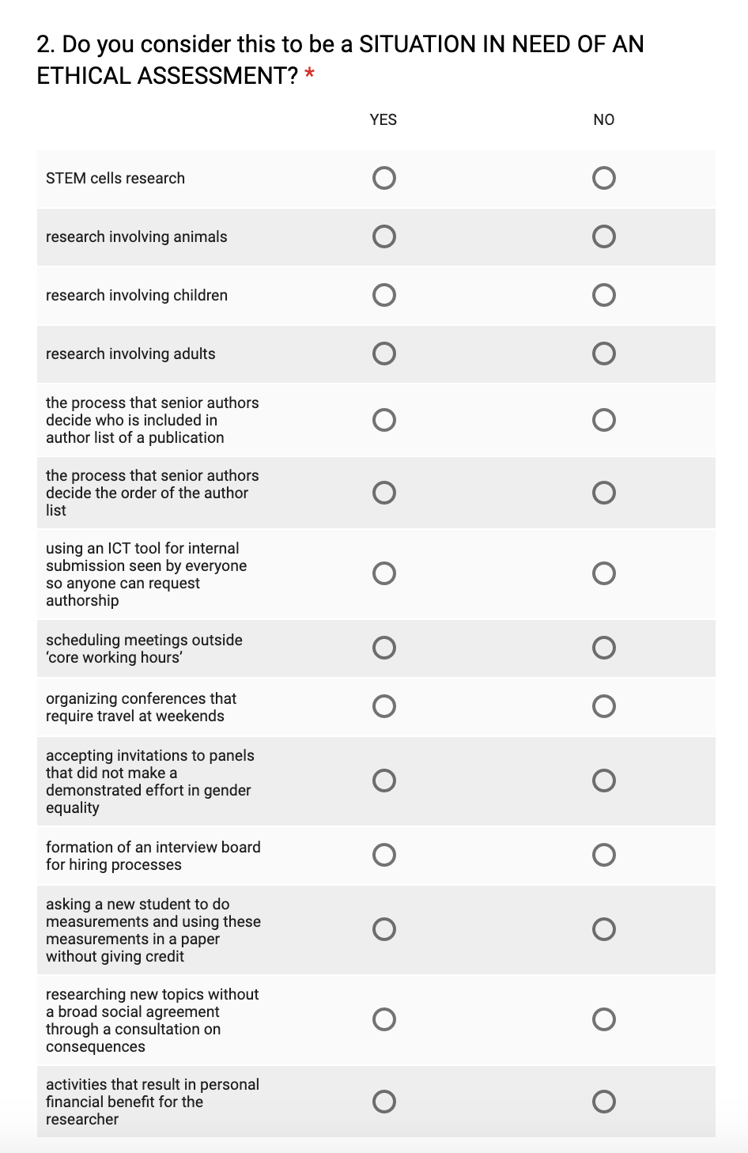Figure 1: The connection between research principles and required ethical monitoring solutions.

## The personal involvement

**The second set of questions** focused on a set of specifically chosen situations, and questioned the necessity for each of these situations to be considered within an ethical assessment.

The focus within this set of questions was on a personal point of view, thus the described situations were described in a very addressing way. The purpose was to emotionally involve the respondent to answer from this or her personal point of view, neglecting the policies that could be in place in the environment he or she operates in.

The idea was to set the scene for later, organizational behavior-based questions. The inherent logic was that the questions and the answers should enable the topic of ethics in everyday research life to become internalized, to be considered as something that we are all connected to, before stating the position of the organization.

Thus, situations as “accepting invitations to panels that did not make a demonstrated effort in gender equality” or “asking a new student to do measurements and using these measurements in a paper without giving him credit” or “the process that senior authors decide the order of the author list” were introduced.

Figure 2: The situations listed to be assessed with respect to the necessity of ethical assessment from a personal point of view.

They were modeled in an inviting and personal way on purpose to incur personal responses.

## The organizational view

The **third part of the enquiry** questioned about a similar, but less personally engaging set of situations, but from the point of view of the organization.

Does the organization itself perceive the situation to need an ethical assessment. Here we tried to see the difference between personal involvement in the ethical issues of personal situations that researchers need to live through and the ones recognized from the side of the institution. The difference to the previous set of questions is obvious. Here we address in a number of simple, straightforward situations, that can be easily understood in any research environment.

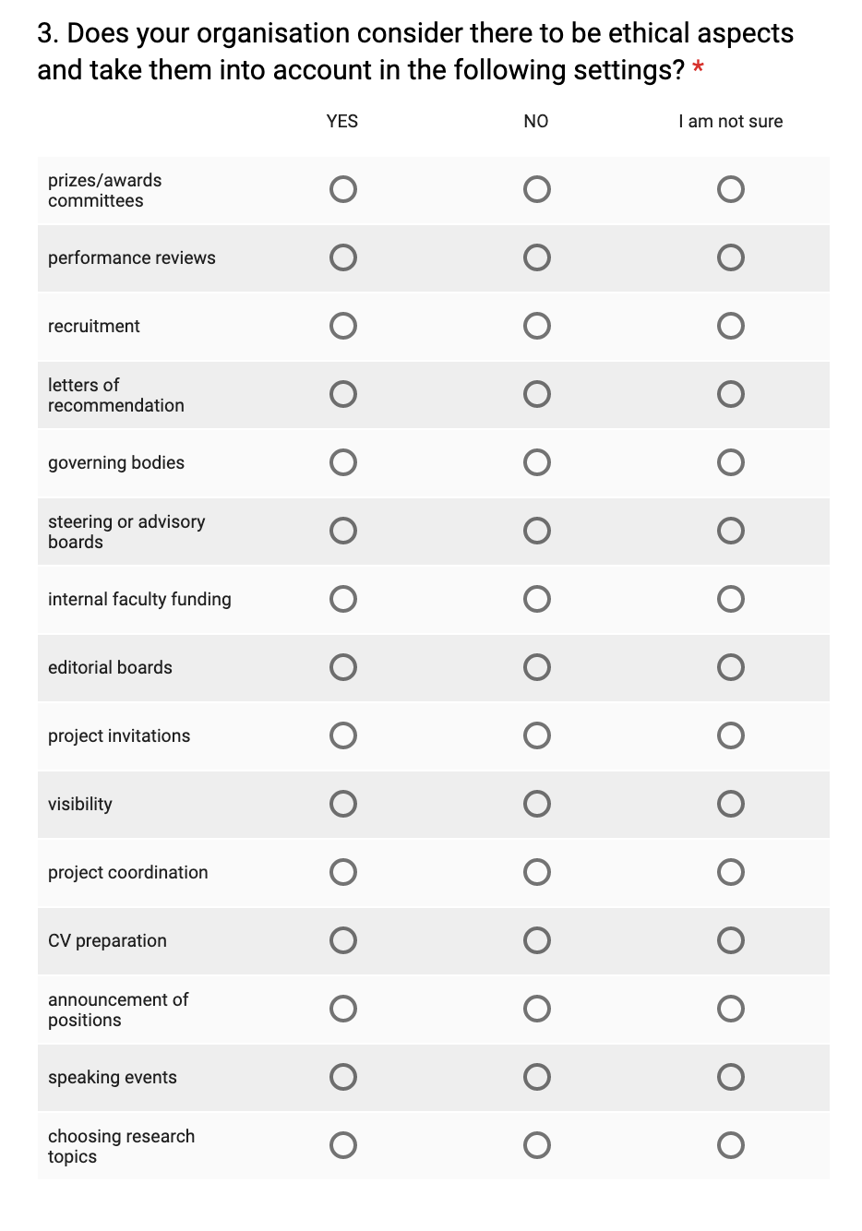

Figure 3: The situations listed to be assessed with respect to the necessity of ethical assessment from an organizational point of view.

As such, they do not carry much emotional co-signature and it is thus more difficult to misinterpret them, but they are also not seen as situations in which the respondent is necessarily involved.

We wanted the respondents to enter the administration point of view, stating the views of the management of the research organization.

## The possible remedies

The **fourth set of questions** focused on possible remedies or solutions that could be used by the organization to address the situations in need of ethical assessment and analyzed the use of such tools.

The listed solutions range from very light ones as for example awareness raising via listing of expectations from the community, which would majorly serve as an encouragement to think about such topics as ethics. Suggested solutions are: Through informal and formal guidelines and code of conduct or a local policy; to more strict and formal measures as the ethical review committee (and several of them in different fields of research) or the enforcement of some detailed procedural documents or policies; to the last and most prescribed solution in the form of a legal framework in terms of a national legislation.

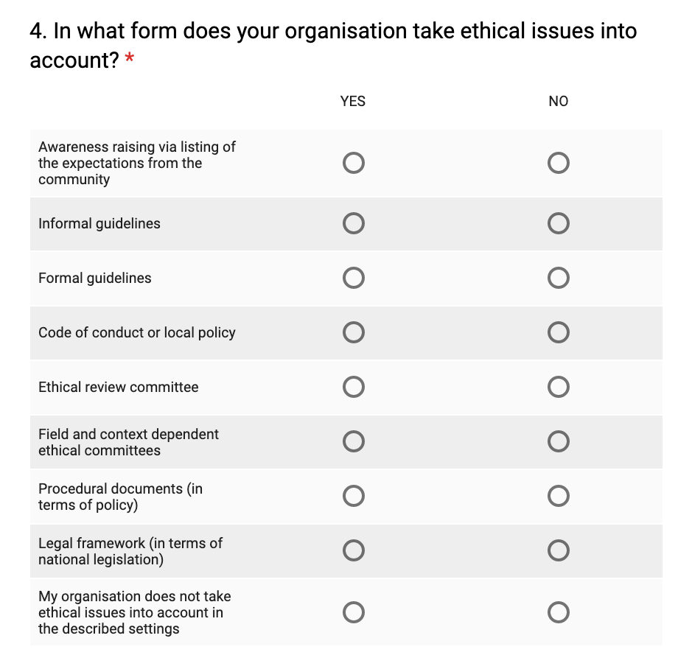

Figure 4: The possible tools to address the situations in need of ethical assessment, from an organizational point of view.

We also offered the option where the respondents could state that their organization does not take ethical issues into account in the described settings.

There were also some **content questions**, assessing the reasons about why and how does/ does not a specific research organization consider there to be ethical aspects and does/ does not take them into account to allow for personal explanations of the ethics in research as seen by the respondents. (in their own words).

In this part we dealt with issues of ethics in research beyond regulatory compliance from a personal point of view: single and outlying views were sought for here. We were interested in issues that the respondents see of interest beyond what is regulated in the sense of animals’ rights and informed consent but could be related to management of science and technology and multilateral collaborations etc.

## The tools available vs. the need

In **the final part** the questionnaire focused on matching the situations in need of ethical assessment with the tools available to deal with them – in particular it focused on the usage of the tools in practice.

Here we tried to understand the relation between the theoretical assessment of the need and the readiness to act on such needs institutionally.

This complex matrix was developed to obtain an insight to the actual type of remedy that the respondent should think would need to be available from the side of the institution, in order to fully address the ethical views on particular situations. The idea was to obtain actual strength of the remedy to be considered with respect to a particular situation. The starting point of the research was that some situations would require stronger remedies than other, but perhaps not all of them would be allowed the same level of 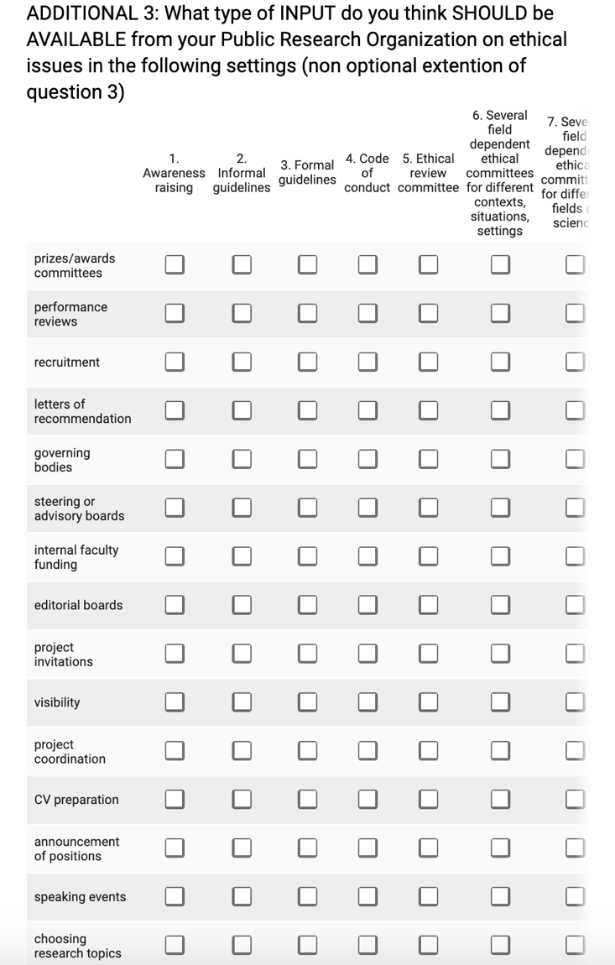interference due to the requested autonomy of the researchers.

Figure 5: The usage of the tools to address the situations in need of ethical assessment, from the organizational point of view.

# CONCLUSIONS

The set up matrix of questions will allow further work and analysis about the use of ethical principles in public research institutions from a multiplicity of points of view: the general attitude, the more personalized point of view, the view of the organization and the possible remedies.

We plan to continue our work in terms of applying the questionnaire to a chosen set of relevant public research organizations in Europe, the JTC TTO Circle [1, 2].

# ACKNOWLEDGMENTS

Our thanks to Michael Bernstein for allowing us the time to develop the attitudes to the questionnaire and to supply us with some important documents in the field. Thanks to Johan Benesch (Chalmers University) and Huw Jones (Aberystwyth University) for their inspiring support in the first phases of setting up the research questions.

# REFERENCES

1. JRC TTO Circle Publication, 18.8.2019, <https://ec.europa.eu/jrc/communities/en/community/tto-circle-community>(.
2. JRC TTO Circle Publication, 18.8.2019, <https://ec.europa.eu/jrc/communities/en/community/european-tto-circle/page/tto-circles-members>)
3. Eric Breit et all.. 2016. Promoting Integrity as an Integral Dimension of Excellence in Research. EU project No. 665926 report.
4. Boucher Philip et al.. Ethics dialogues. Experiencing Ethics through ‘things’. 2014. ISBN 978-92-79-45049-5
5. WIPO. 2017 WIPO. Successful Technology Licensing. Publication No. 903E 2015 Edition ISBN 978-92-805-2633-2
6. Ellen‑Marie Forsberg et al.. 2018. EUROPEAN CONSENSUS STATEMENT. Sci Eng Ethics, 24:1023–1034. Working with Research Integrity — Guidance for Research Performing Organizations: The Bonn PRINTEGER Statement. https://doi.org/10.1007/s11948-018-0034-4