Modelling Natural Selection to Understand Evolution of Perceptual Veridicality and its Reaction to Sensorimotor Embodiment

Tine Kolenik
Jožef Stefan Institute & Jožef Stefan International Postgraduate School
Jamova cesta 39
1000 Ljubljana, Slovenia
+386 1 477 3807
tine.kolenik@ijs.si

ABSTRACT
The relationship between mind and world has always been one of the focal interests of cognitive science. Perception has been identified as one of the main sources of knowledge about the world and therefore a prime research interest. Evolutionary scientists claim that natural selection optimizes perception so that it accurately mirrors the outside world. In opposition, the interface theory of perception proposes that perception is a non-veridical interface between an organism and the outside world, evolutionarily fitted to the organism’s fitness and not the objective truth. It has been studied using genetic algorithms (GAs), which show that non-veridical perception offers more survival value to the modelled organism than veridical perception. However, the theory is based on cognitivist presuppositions about the mind, claiming that perception does not require action. We successfully replicated the GA model, then replaced cognitivist presuppositions with embodied-enactivist presuppositions, coupling action and perception by adding a sensorimotor loop. The sensorimotor loop bootstraps evolution, with organisms needing less information to perform better due to knowing how to perceive by taking appropriate actions. We also perform additional experiments to further corroborate our claims.
Keywords
Cognitivism, enactivism, evolution, genetic algorithms, interface theory of perception.

INTRODUCTION
Perceptions have evolved not to describe the objective world, but to help us survive. In a way, they are similar to a computer desktop, which shows its elements, like icons, as to make them easily manipulatable, but ‘hides the truth’ behind them, like the underlying electrical current. This is the main idea of the interface theory of perception (ITP) [1].
Hoffman et al. [1] claim that perceptions are not isomorphic to the objective world, but to the evolutionary fitness of the perceiving organism. ITP therefore follows a more general upheaval in cognitive science (predictive coding [2], enactive approaches [3]) that goes against the idea that perception generates “a fully spatial virtual-reality replica of the external world in an internal representation.” [4, p. 375]. Hoffman et al. use, among other methods, genetic algorithms (GAs) to back up their theory [5]. Their model generates a population of artificial organisms that can perceive and act, and evolves them. After a number of generations, the organisms that survive and reproduce do not perceive the objective world isomorphically – rather, they perceive it according to their internal needs, isomorphic to their payoff function.
In our work, we replicate their GA model. Hoffman et al. make a cognitivist claim that perceptual experience does not require motor movement [1, p. 1497]. We believe that is not true, following enactive approaches to sensorimotor cognition [6], and make our own GA model. In it, we replace cognitivist presuppositions with embodied-enactivist ones by adding a sensorimotor loop. This also serves to offer further evidence for ITP’s idea.

REPLICATION
Hoffman et al.’s cognitivist model (CM) is based on Mitchell’s ‘Robby, the Soda-Can-Collecting Robot’ [7]. Robby is an agent that forages soda cans scattered on a grid (Figure 1). It can make a move in a Von Neumann neighborhood, which it perceives, as well as try to pick up a soda can. It gets points if there is a soda can in the cell it stands on. It loses points if there is no soda can or if it bumps into a wall surrounding the grid. The GA model generates many such grids with many Robbies, who start out with very bad strategies for foraging. Through evolution, where Robbies with better strategies are selected for DNA crossover, Robbies in the final generation become masters of their craft. Their DNA is composed of situation-move pairs, where the situation part describes a possible configuration of soda cans in a Von Neumann neighborhood, and the move part describes which move to make when Robby is in that situation.
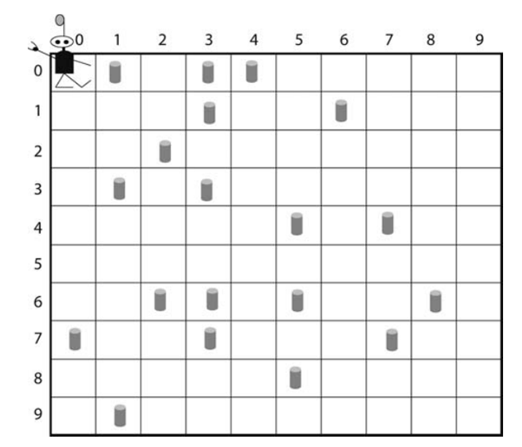
Figure 1. Robby and its world [from 6, p. 131].
Hoffman et al. modify Mitchell’s model in a number of ways to be able to investigate ITP. They add a perceptual DNA (pDNA) to Robbies alongside their foraging DNA (fDNA) to evolve as well. The pDNA determines how Robbies see the cells in their Von Neumann neighborhood. They either see them colored in red or in green, depending on the number of soda cans in the perceived cell and their pDNA. As implied, Hoffman et al. also changed the number of possible soda cans in a cell from up to 1 to up to 10. The points Robbies get from picking up soda cans are modified as well – the payoff function is Gaussian, Robbies get (0,1,3,6,9,10,9,6,3,1,0) points for (0,1,2,3,4,5,6,7,8,9,10) cans, respectively (see Figure 2). Each gene in the pDNA represents one amount of soda cans, connecting it with one of the two colors.
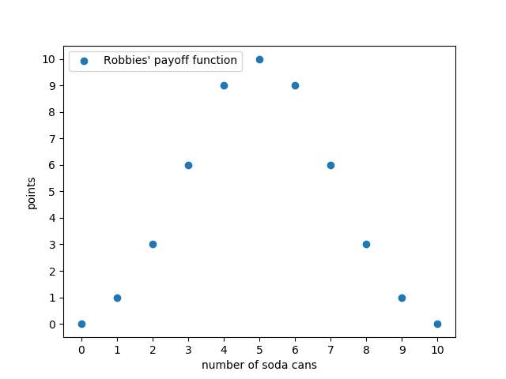
Figure 2. Robbies’ Gaussian payoff function for foraging soda cans.
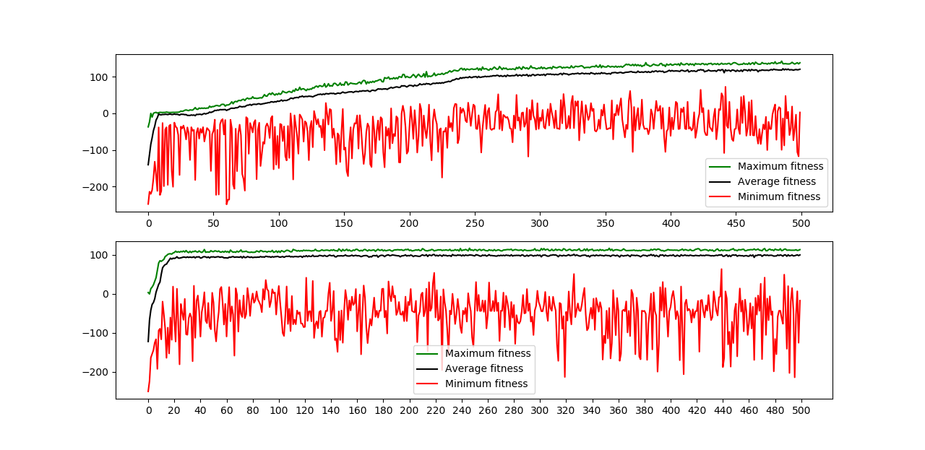
Robbies evolve similarly as in Mitchell’s model – they start with bad strategies and end with good ones. What is of interest is how their pDNA evolves during this time – the question is whether the perception is isomorphic or non-isomorphic to the outside world. If the pDNA were to evolve to be isomorphic, it would look like the top genome in Figure 3, which makes colors organize to reflect the lower and the higher amounts of soda cans. If it were to evolve to be non-isomorphic, it would look like the bottom genome in Figure 3, reflecting Robbies' fitness function. It is the latter that does evolve, making Robbies not see the world isomorphic to the outside world, but in a way that helps them survive – the number of soda cans that brings them the most points are of one color, the number that brings them the least points are of another color.
Figure 4. Robbies’ foraging skills evolution in CM (top) and EAM (bottom).
Figure 3. Isomorphic (top) and non-isomorphic (bottom) perceptual DNA.

EMBODIED-ENACTIVE MODEL
We look at ITP from an embodied-enactive perspective, especially since Hoffman et al. claim that perception is possible without action. Therefore, we add a sensorimotor loop to Robbies. Our model’s (EAM) modifications are the following: previously able to see the Von Neumann neighborhood, now Robbies only see the cell they are in and the cell they are looking at. The latter implies another modification – Robbies first have to act to perceive. They have to turn towards a certain direction to see the cell in that direction. Robby therefore has the following ‘loop of life’:
- Depending on where Robby is looking at, perceive the cell’s color.
- Make a move depending on what Robby sees in the direction it is looking at and the cell it is standing on.
- Decide which cell to turn to, which will be perceived in step 1 of the process’ reiteration.
The fDNA is modified to include turn-situation-move triplets, which are then evolved instead of only situation-move pairs as in CM. Figure 4 shows the results of how Robbies and their fitness (number of points on y-axis) evolve (time on x-axis) with CM on the top and EAM on the bottom. EAM’s Robbies’ pDNA evolves the same as in CM.

ADDITIONAL EXPERIMENTS
Four additional experiments were made with CM and EAM to further examine legitimacy of non-isomorphic perception prevailing over isomorphic perception. Robbies were implemented with pDNA coding the mapping from the external world to colors that was constant, unchanged neither by crossover nor by mutation. Four experiments were run:
- CM was implemented with a fixed isomorphic perceptual strategy.
- CM model was implemented with a fixed non-isomorphic perceptual strategy.
- EAM was implemented with a fixed isomorphic perceptual strategy.
- EAM was implemented with a fixed non-isomorphic perceptual strategy.
Figures 5, 6, 7 and 8 show graphs for CM with a fixed isomorphic perceptual strategy, CM with a fixed non-isomorphic perceptual strategy, EAM with a fixed isomorphic perceptual strategy and EAM with a fixed non-isomorphic perceptual strategy, respectively.
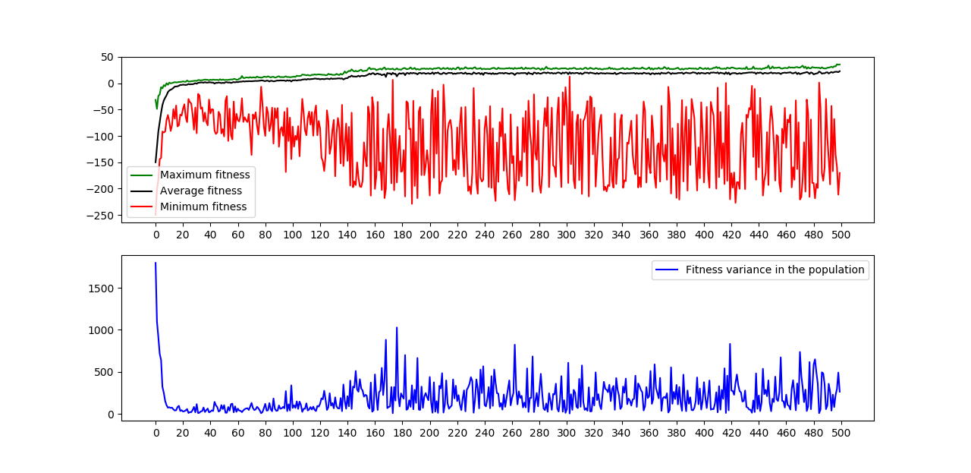
Figure 5. CM with a fixed isomorphic perceptual strategy. The top graph shows the fitness score over generations, the bottom graph shows fitness score variance over generations.
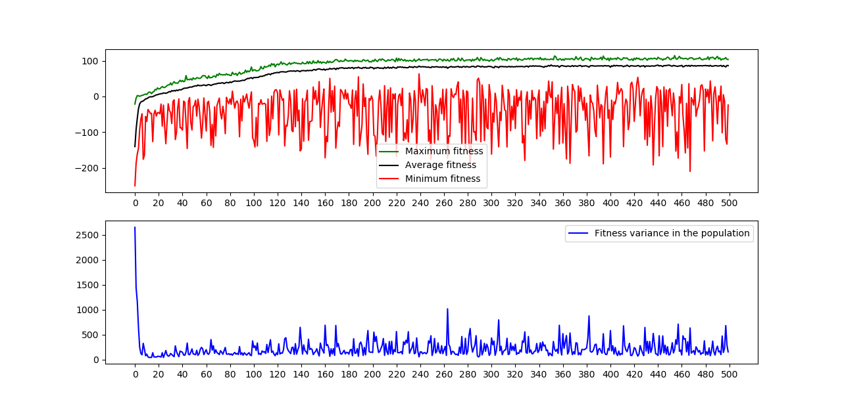
Figure 6. CM with a fixed non-isomorphic perceptual strategy. The top graph shows the fitness score over generations, the bottom graph shows fitness score variance over generations.
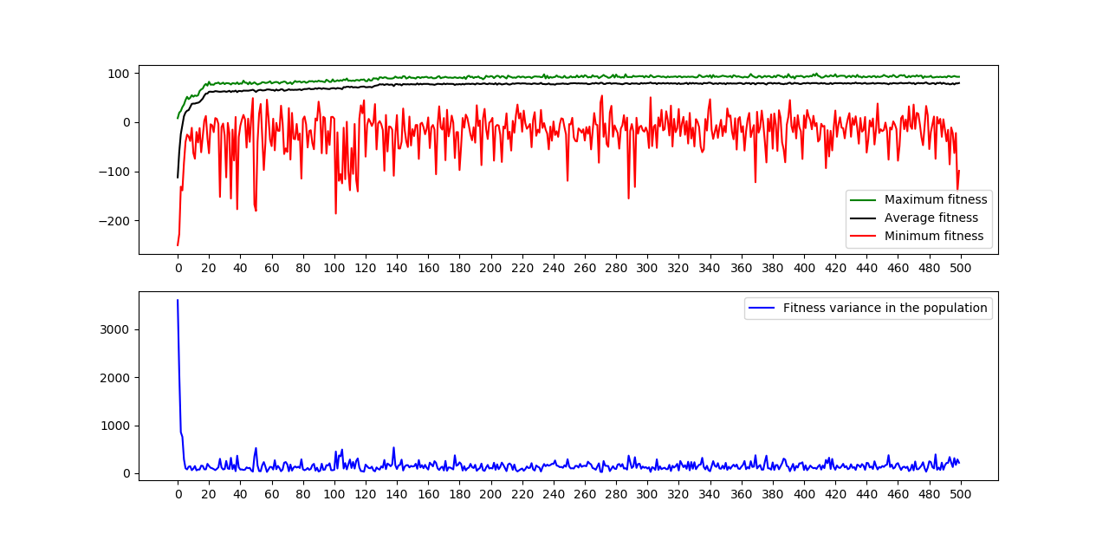
Figure 7. EAM with a fixed isomorphic perceptual strategy. The top graph shows the fitness score over generations, the bottom graph shows fitness score variance over generations.
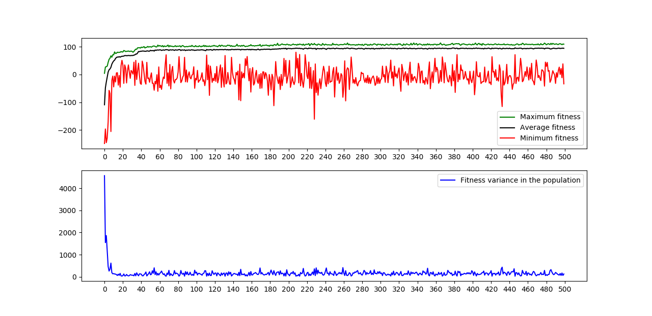
Figure 8. EAM with a fixed non-isomorphic perceptual strategy. The top graph shows the fitness score over generations, the bottom graph shows fitness score variance over generations.
Experiments mostly yielded nothing out of the usual. Both models with non-isomorphic perceptual strategies scored similarly between each other as well as to the original models without fixed, but evolving perceptual strategies. The slope of CM’s two graphs compared to EAM’s are again to be expected – the same happened in the models with evolving strategies. The same goes for variance. What is unexpected is that Robbies with isomorphic perceptual strategies in EAM score a lot higher than Robbies with the same perceptual strategy in CM. This might be again due to the varying variance and higher scoring individuals in EAM, where the sensorimotor loop works as an optimizer.
Further experiments therefore yielded results that were expected, and showed that the fitness-based, non-isomorphic perceptual strategy makes Robbies more successful in picking up soda cans and navigating the modelled world.

DISCUSSION AND CONCLUSIONS
CM and EAM both evolve perceptions that are not isomorphic to the objective world, but rather to the perceiving organism’s needs. However, they diverge in how long it takes for Robbies to become master foragers. EAM implements active perception [8], which bootstraps evolution and optimizes the best foraging strategy discovery process. This means that actively choosing which (and less) information to take in beats more (‘free’) information which needs to be processed in CM. In our future work, we want to make Robbies more ‘enactively’ autonomous [9] and their fitness function more dependent on historical interactions [10] as well as conceptualize the role of such modelling in researching how presuppositions of different cognitive science paradigms influence our understanding of cognition [11].

ACKNOWLEDGEMENTS
I thank Urban Kordeš for his mentorship of the Master’s thesis, which served as the foundation for this work.

REFERENCES
- Hoffman, D. D., Singh, M. and Prakash, C. 2015. The interface theory of perception. Psychonomic Bulletin & Review. 22 (2015), 1480–1506. DOI= https://doi.org/10.3758/s13423-015-0890-8.
- Clark, A. 2013. Whatever next? Predictive brains, situated agents, and the future of cognitive science. Behavioral and Brain Sciences. 36 (2013), 181-204. DOI= https://doi.org/10.1017/s0140525x12000477.
- Ward, D., Silverman, D., and Villalobos, M. 2017. Introduction: The varieties of enactivism. Topoi, 36, 3 (2017), 365–375. DOI= https://doi.org/10.1007/s11245-017-9484-6.
- Lehar, S. 2003. Gestalt isomorphism and the primacy of subjective conscious experience: a Gestalt Bubble model. Behavioral and Brain Sciences, 26, 4 (2003), 375–444. DOI= https://doi.org/10.1017/s0140525x03000098.
- Mitchell, M. 1999. An introduction to genetic algorithms. The MIT Press, Cambridge, MA.
- Di Paolo, E., Buhrmann, T., and Barandiaran, X. E. 2017. Sensorimotor life: an enactive proposal. Oxford University Press, Oxford.
- Mitchell, M. 2011. Complexity: A Guided Tour. Oxford University Press, Oxford.
- Jug, J., Kolenik, T., Ofner, A., and Farkaš, I. 2018. Computational model of enactive visuospatial mental imagery using saccadic perceptual actions. Cognitive Systems Research, 49 (2018), 157–177. DOI= https://doi.org/10.1016/j.cogsys.2018.01.005.
- Kolenik, T. 2016. Embodied Cognitive Robotics, the Question of Meaning and the Necessity of Non-Trivial Autonomy. In Cognitive science: proceedings of the 19th International Multiconference Information Society – IS 2016 (Ljubljana, Slovenia, October 13, 2016). Jožef Stefan Institute, 24–27.
- Oyama, S. 1985. The ontogeny of information: developmental systems and evolution. Cambridge University Press, Cambridge.
- Kolenik, T. 2018. Seeking after the Glitter of Intelligence in the Base Metal of Computing: The Scope and Limits of Computational Models in Researching Cognitive Phenomena. Interdisciplinary Description of Complex Systems, 16, 4 (2018), 545–557.

