**A Survey of the Harmonic Existence of Green Computing in Knowledge Society**

Amin Fakhereldine, Mahdi Dhaini, Mohammad Jaber, Sleiman Hamdan and Ramzi A. Haraty

Department of Computer Science and Mathematics

Lebanese American University

Beirut, Lebanon

Email: rharaty@lau.edu.lb

ABSTRACT

The upsurge in global warming and release of greenhouse gases is a major issue that intensified over the past years due to the increasing usage of technological resources in our daily routines. That is why a call for going green in the technological field is hardly recommended. This paper reviews various approaches of green computing in five main models - software engineering model, cloud computing, mobile computing, data centers, and educational sector.

KEYWORDS

Green computing, Sustainable development, Models, Cloud computing, Mobile development, Education, and Data centers.

# Introduction

Global warming and climate change are causing the increase of global temperature and the rise of sea levels. The main cause of environmental impacts is people and their harmful behavior. As an example, for such behaviors are the huge amounts of CO2 emissions from the industries and vehicles, cutting trees, and the exhaustive use of resources by technology. Studies have showed that the amount of CO2 emissions have been increasing in the past few years [1]. Efforts for reducing harm on the environment must start from changing peoples’ behaviors. Citizens of the planet Earth are responsible for thinking “Green” in all aspects of their lives in order to save and protect their future on their planet. Nowadays, technology has entered people’s lives deeply, until it reached their jobs, homes, and education. As a contribution to achieve environmental sustainability, people can start from changing the way they deal with technology. Most efforts addressed the hardware perspective of green computing with little attention to the importance of the software perspective. Efficient software reduces the use of hardware resources; therefore, reducing energy consumption. In this study, we examine different green computing approaches in the literature in various domains of software development. In particular, we study green approaches in software engineering models, cloud computing, mobile development, data centers. In addition, we highlight the importance of introducing green computing principles in the educational sector.

The remainder of this paper is organized as follows. Section 2 provides a literature review. Section 3 presents the models for sustainable software engineering. Section 4 handles green cloud computing. Section 5 tackles green mobile development. Section 6 deals with green data centers. Section 7 discusses green computing in education. And section 8 concludes the paper.

Permission to make digital or hard copies of part or all of this work for personal or classroom use is granted without fee provided that copies are not made or distributed for profit or commercial advantage and that copies bear this notice and the full citation on the first page. Copyrights for third-party components of this work must be honored. For all other uses, contact the owner/author(s).

22nd International Scientific Multiconference "Information Society" – IS 2019 (October 7 - 11, 2019, Ljubljana, Slovenia

© 2018 Copyright held by the owner/author(s). 978-1-4503-0000-0/18/06...$15.00

# Literature Review

Many efforts were done in the literature with the aim of achieving green computing in different domains and reducing the negative impacts of ICT on the environmental sustainability. Naumann et al. [2] presented a reference model for sustainable software engineering (GREENSOFT) that supports different stakeholders in the whole lifecycle of software production. Berkhout and Hertin [3] defined three levels of ICT impacts on the environment and highlighted the importance of studying their rebound effect in which negative impacts over compensates positive ones. Mahmoud and Ahmad [4] defined green metrics in the stages of software production and stressed on the importance of two stages: requirements definition and testing. The model also discusses the role of software itself in achieving green computing. Capra et al. [5] studied the impacts of software on sustainability and proved that achieving a better performance does not guarantee better energy efficiency.

Atrey et al. [6] studied how the cost of the unlimited services of cloud computing leads to overcompensating the benefits and increases energy consumption and CO2 emissions. Dougherty et al. [7] described a model-driven green technique to avoid over-provisioning of idle virtual resources in cloud servers. The aim of this model is to provide a green auto-scaling technique, for allocating VM configurations, that preserves a satisfactory QoS. The problem is solved as a feature selection problem. Gai et al. [8] presented an energy-aware mobile cloud computing model that takes advantage of cloudlets to reduce energy consumption of wireless communications. Xu et al. [9] described an energy efficient algorithm for VM scheduling inspired by physical principles. Zhao-Hui and Qin-Ming [10] proposed a virtual machine scheduling algorithm that deploys VMs on data nodes with the least growth of energy consumption. Mukhtar et al. [11] presented a green strategy for determining the least energy consuming fog device to offload client application modules. Verma S. et al. [12] presented an energy efficient, but costly, algorithm that integrates load balancing and data replication for Fog-Cloud computing. Previous researches acknowledge that by using virtualization CC (cloud computing) is itself energy efficient technology [13]. A.J. Younge and his colleagues proposed a green cloud framework a few years ago, but it covered only virtualization and data center operations [14]. Haraty and Hu presented a study of software process models including models to develop green software [15].

Green Computing is responsible for designing, manufacturing, using, and disposing of computers, servers, and its hardware like monitors, printers, storage devices, and networking and communications systems in order to consume efficiently and effectively with minimal or no impact on the environment [16]. Mobile devices are becoming an important and irreplaceable resource in our daily life. According to the International Telecommunication Union, the number of registers in the worldwide mobile network operators has already reached more than 4 billion of users [17]. Moreover, based on the International Data Corporation’s statistics, 494 million smartphones were sold worldwide in 2011. The sales of smartphones reached an annual growth of 62% from 2010 till 2011, expecting this increase to continue furthermore [18]. With this huge number of mobiles and mobile users, and taking into consideration their effect on the environment, regarding their energy consumption and the toxic wastes, one should think of a solution that preserves the environment and prevent harming it. Many approaches have tried to reduce the burden of mobile devices; probably the most common one is trying to execute heavy computational operations on the cloud rather than executing them on mobile devices. For example, CloneCloud [19] is a system that allows partial offloading from smartphones to the phone’s clone in the cloud. A similar idea was also investigated by Satyanarayanan et al. [20] and Cuervo et al. [21]. Another example from Chen et al. [22] who introduces a framework allowing heavy tasks on an Android phone to be offloaded to an Android virtual machine in the cloud. On the other hand, others suggest that mobile devices could be the source of computing power.

When talking about going green in an environment that encounters rapid ongoing changes in the technological fields, the need for a business to “Go Green” is much needed to help reduce the hazardous outcomes that humanity is facing. And for an industry to “Go Green” it must simply maintain an ecofriendly and energy efficient computing resources. Green data centers view a great aspect into offering an energy efficient and ecofriendly computing environment. The burst of data centers began from 1946 where data centers where created by U.S. army to serve the military [23]. And throughout the years the idea of placing data centers has increased and we began to see data centers placed more often in industries. They also mentioned that data centers are defined simply by information and server storage as well as network infrastructure of the company’s huge amount of data. And because of this aspect being spread, and adding to that the rapid booming that the world encountered in the field of technology, the consumption of energy became larger and emission of toxics increased as well. That opened the door for data centers to go green and become more and more ecofriendly. A green data center differs from a normal data center through the mechanical, electrical, and computer infrastructure is designed in a way to obtain maximum energy efficiency and minimum environmental damages [24]. Nada and Elgelany [25] mentioned in their article that data center consumes a huge amount of energy as the same time it plays a major role in producing large amount of carbon dioxide due to a fact that data centers are mainly composed of thousands of servers. Uddin et al. [26] mentioned in their study that a data center is composed of thousands of servers and is equal of the amount of a small city.

The topic of green computing in the education sector has been studied intensively in the literature. Many studies were conducted to assess the awareness and knowledge levels of green computing in educational institutions [27, 28]. In [28], a study was conducted to check the level of awareness of green computing among students in the University of Technology in Mauritius. In [29], German software users were surveyed for a study that addressed the environmental issues of software. The integration of sustainability into computing education was studied in [30], where three different strategies were presented. In [31], different techniques for practicing green computing in universities were proposed.

# Models For Sustainable Software Engineering

Berkhout and Hertin [3] studied the impacts caused by Information and Communication Technologies (ICTs) on the environment. They presented a summary of the literature on the topic and classified the environmental impacts of ICTs into 3 categories as follows:

* *First-order impacts:* the most obvious environmental impacts that result directly from the production and use of ICT infrastructure and devices such as resource use and pollution, electricity consumption of ICT hardware, and disposal of electronic waste.
* *Second-order impacts:* indirect environmental impacts of using ICT such as resource and energy conservation caused by dematerialization, demobilization and substitution of information goods for tangible goods.
* *Third-order impacts:* indirect environmental impacts of using ICT that appears on the long term such as changing life styles and values systems. These impacts may over compensate the energy savings by ICT (rebound effects).

The authors identify that ICTs have both positive and negative impacts, as shown in Table 1, and that each order effects appear based on the previous order effects (second based on the first, and third based on the second order effects).

**Table 1: ICT impacts on the environment. Reprinted from [3]**

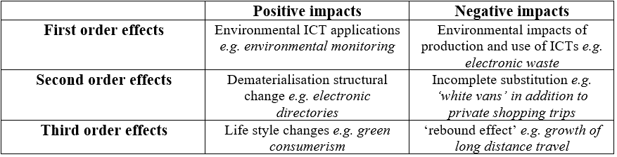

A major issue stressed in relation to the third order effects is the ***rebound effect*** of the use of ICT. It has been shown, through the first and second order effects, that ICTs have the potential to reduce resources usages and energy consumption. However, a critical question is whether or not the long-term consumption of ICTs will overcompensate the conserved resources. This concept is presented as the ***rebound effect***.

Naumann et al. [2] presented a reference model for Green and Sustainable software named *GREENSOFT* and gave definitions for *Green and Sustainable Software* and *Green and Sustainable Software Engineering*. The model also performs a refinement for the environmental impacts of ICT, defined by Berkhout and Hertin [3], to cover human and social sustainability issues instead of limiting them to environmental issues. The effects were identified as:

* effects of ICT supply (representing *first-order* effects)
* effects of ICT usage (representing *second-order* effects)
* systemic effects of ICT (representing *third-order* effects)

Naumann et al. [2] claimed that a sustainable software product should have a low impact on *Sustainable Development*, and that the development process of the software product should be environment-friendly. This is reflected in the definitions of *Green and Sustainable Software* and *Green and Sustainable Software Engineering* that was provided:

**Green and Sustainable Software:** is software that leaves a small footprint on the environment.

**Green and Sustainable Software Engineering:** is the art of defining and developing software products in a way, so that the negative and positive impacts on sustainable development that result and/or are expected to result from the software product over its whole life cycle are continuously assessed, documented, and used for a further optimization of the software product.

The *GREENSOFT* model also supports different stakeholders of a software product (developers, administrators, users) in developing, maintaining, and using it in a sustainable manner. The model, as shown in Figure 1, comprises the following four parts:

* 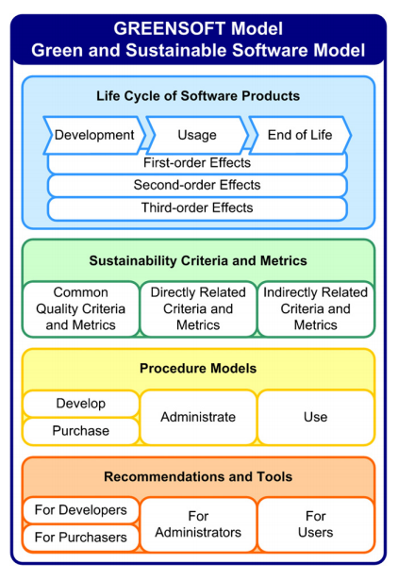*Life Cycle of Software Products:* Based on the three levels of impacts, it directs stakeholders to take into consideration the impacts on *Sustainable Development* during development, distribution, usage, deactivation and disposal phases
* *Sustainability Criteria and Metrics:* Defines metrics and criteria helpful for the assessment of a software product’s sustainability.
* *Procedure Models:* Classifies the software life cycle into four sub-procedure models and proposes a set of activities and processes that are geared towards sustainable development in each model. The four sub-models are: Develop, Purchase, Administrate, and Use.
* *Recommendations and Tools:* This part guides every stakeholder of a software product to comply with green guidelines and procedures while dealing with the software product.

Mahmoud and Ahmad [4] proposed a model for a green software engineering process consisting two levels (described below). The first level comprises metrics for the green assessment of every stage in the software engineering process according to the ICT *first-order impacts*. The second level of the model, addresses the role of software itself in sustainable development and green computing. The model followed the definitions of *Green and Sustainable Software* and *Green and Sustainable Software Engineering* presented by Naumann et al. [2] and their definition of ICT impacts because they consider human and social sustainability issues. [4] also included an additional definition which is *Green and Sustainable Software Process* because their aim is to provide green instructions for the whole lifecycle of software production.

**Figure 1: The GREENSOFT model. Reprinted from [2]**

## First Level

This level defines a software engineering process to mitigate the negative impacts of ICT on the environment. The process consists of seven stages of the lifecycle of a software product: requirements, design and implementation, testing, green analysis, usage, maintenance, and disposal. The model describes instructions and guidelines that can be used for the green performance of each stage. In the model proposed by Naumann et al. [2], the part of *Life Cycle of Software Products* discusses impacts of ICT on sustainable development in stages of the product’s lifecycle. However, they do not include requirements and testing stages. These two stages were considered in [3] in contrast to many green software models. In addition, a green analysis stage was added to measure the greenness of the output of every stage. We will particularly discuss the importance of including these three additional stages in a green software process:

* *Requirements Stage:* in this stage, the model recommends that requirements engineers will perform requirements Functionalities. Therefore, the rate of changes in the software will be reduced, and resources needed for changes will be conserved.
* *Testing Stage:*this stage helps the developing organization to evaluate the compliance of the software product with the customer’s requirements. Therefore, it limits the chances of going back to the requirements stage in case the products do not meet the customer’s satisfaction. The resources needed for going back to previous stages will thus be conserved.
* *Green Analysis Stage:*the objective of this stage is measuring the “greenness” of the outputs of other stages and allowing for going back to previous stages in order to apply changes that aid green and sustainable development.

## Second Level

Another idea missing from the *GREENSOFT* model [2] is software’s role in reducing the negative impacts of ICT and improving sustainable development. The second level of the model presented by Mahmoud and Ahmad [3] describes how software can act as a tool to monitor efficient use of resources. Several software packages that aid in regulating resource consumption are presented in this level such as operating systems, codes written for energy allocation purposes and some approaches like *SPAN* [32] that correlates power estimation with source codes, and *GREENTRACKER* [33] that measures energy consumption.

# Green Cloud Computing

Cloud computing reduces power consumption by providing cloud applications with virtualized computational resources dynamically upon request such as virtual OS instances. This technique requires keeping idle VM instances in a queue as standby for any request. Consequently, 70-80% of power consumption in data centers is wasted [34-37]. In order to avoid over-provisioning of idle resources, *Auto-scaling* technique was introduced to improve server utilization of resources and support greener cloud computing by allocating virtualized computational resources, dynamically and accurately, to cloud applications based on their current loads. *Auto* in an *auto-scaling queue* to be provisioned instantly to cloud applications. If no entry in the queue matches the requested configuration, a new VM will be booted and configured then provided to the requesting application. This mechanism is shown in Figure 2. The objective is to maintain the *auto-scaling queue* in a green manner while preserving *QoS*. A preferred *auto-scaling queue* is a one that reduces energy and resources consumption by minimizing the number of idle VMs. However, it is very difficult to determine the number of VMs to fill the queue and their configurations. Examples of configuration options provided by Amazon EC2: Linux vs Windows operating systems, SQL Server vs MySQL databases, Apache HTTP vs IIS/Asp.Net webhosts [7].

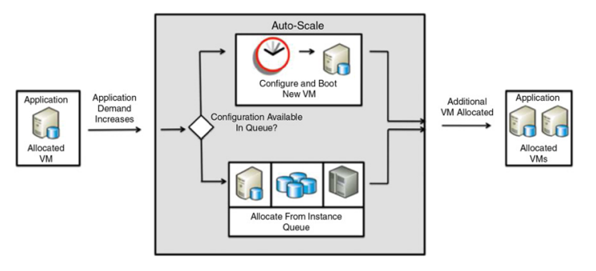

**Figure 2: Auto-scaling in a cloud infrastructure. Reprinted from [7].**

Dougherty et al. [7] describes a model-driven green technique for sustainable *auto scaling* cloud computing infrastructures called *Smart Cloud Optimization for Resource Configuration Handling* (SCORCH)*.* The authors mention three main challenges of configuring VMs:

* The need for recognizing the VM configuration options of cloud applications (processors, OS) and their constraints (power consumption).
* The choice of VM configurations to be kept in the auto-scaling queue that can warrant a satisfactory QoS.
* Determining the optimal auto-scaling queue size that minimizes energy consumption.

*SCORCH* addresses these challenges based on the following functionalities:

* *Feature models* [33] are used to represent VM configurations, implementation details (*e.g.* whether to use Windows 7 or Redhat 9), and other information about the configurations (*e.g.*, energy consumption, operating costs)
* Cloud applications are requested to inform *SCORCH* about the VM configurations that it will ask for during its lifetime.
* Feature configuration problems are transformed into constraint satisfaction problems (*CSPs*) and an objective function is defined, to aid in deciding on the appropriate settings of the *auto-scaling queue*, taking into consideration several parameters (mainly: expected response time, expected time to fulfill a request, time to boot a new VM instance, and energy consumption of configurations).
* Optimizing the objective function, using a standard constraint solver, yields a combination of VM configurations that minimizes the number of idle VMs to be maintained in the *auto-scaling queue*, minimizes the operation costs, and respects the satisfactory *QoS* and response time requirements.

Experimental studies were run to assess the contributions of SCORCH in green cloud computing. It was compared with two approaches: the first does not consider auto-*scaling*, while the second provides auto-scaling without optimizing the queue. The first approach performed worst while SCORCH performed the best and reduced cost, power consumption, and CO2 emissions by 50% [7].

*Mobile cloud computing* allows mobile users to have a green experience in using their mobiles in terms of offloading data processing and storage to cloud-based servers. However, the greenness of this approach is linked directly to the stability and efficiency of the wireless communications where weak communications cause waste of energy and resources due to the continuous search for wireless signals. As an approach to solve this problem, Gai et al. [8] introduced a dynamic energy-aware cloudlet-based mobile cloud computing model (*DECM*) that takes advantage of cloudlets to reduce the amount of energy consumed by wireless communications. The *DECM* mainly consists of the mobile devices, cloudlets supported by dynamic searching, and cloud computing as shown in Figure 3. The main objective of the model is to provide green computing on mobile devices without affecting the *QoS* in cloud services.

In this model, the nearest cloudlets receive requests from mobiles through the virtual machines corresponding to client applications. A cloudlet may switch a client’s connections to another one if it can provide better service based on a more stable network, nearer location, or greener computations. Cloudlets are coupled with dynamic programming algorithms that enable them to find the most convenient cloud servers to connect with. They are named *DCLs* (Dynamic Cloudlets) in this model. This technique guarantees that the mobile devices and the cloud servers will communicate in the most efficient way. The *DECM* algorithm is a minimizing algorithm for the cost of the wireless communications in *mobile cloud computing*. The two factors affecting the cost is the energy consumption in a communication route (between mobile, cloudlet, and server), and the service performance provided by a specific route (in order to have a satisfactory *QoS*). This algorithm will ensure that *MCC* will perform with minimum energy consumption. This was proved experimentally by comparing the approach with others techniques.

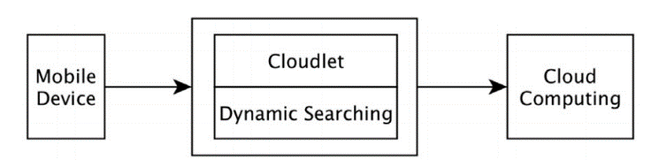

**Figure 3: A high level conceptual model of DECM. Reprinted from [8]**

Xu et al. [9] addressed the issue of VM scheduling algorithms that affect the efficient migration of virtual machines between nodes of the cloud. The authors stress that efficient algorithms for scheduling and migration of VMs are crucial because an inefficient virtualization of resources will cause unnecessary waste, increase in CO2 emissions, and overheating inside data centers. In order to solve this problem, Xu et al. [9] presented a VM scheduling algorithm, *VMSAGE*, inspired by the physical gravitational effect. The algorithm is proposed as an improvement of the simple scheduling algorithms that are based generally on placing VMs on nodes with low memory usage (CPU, RAM) without considering other factors such as heat distribution. *VMSAGE* aids in avoiding overheating in data centers, reducing energy consumption, load balancing, and energy efficiency.

According to the physical concept of gravitation, the algorithm shuts down data nodes having a low utilization rate and migrates its VMs to other nodes with good heat dissipation in order to avoid overheating. The algorithm also uses another physical concept: “among two objects, having the same acceleration, the one with higher initial velocity will reach its destination faster”. Each VM is thus assigned an initial speed of migration in order to enable the system to decide which VMs will migrate before others. VMs with very high utilization rates, having large amounts of resources, or placed in servers with very high temperatures are assigned higher values of initial VMs than others. VMs are migrated to other servers that are selected based on lower costs of migration and heat dissipation.

The objective of *VMSAGE* is to reach a point where no server is in need to reschedule its VMs. In order to assess the algorithm, it was compared with two approaches: *Best Fit Heuristic*, and *Dynamic voltage and Frequency Scaling*. The comparison was based on energy consumption, performance and heat distribution in the data centers. The experimental results showed that *VMSAGE* reduces energy consumption rates and VM migration times significantly.

The *Cloud of Things* paradigm *(CoT)* was introduced to overcome the problems of limited storage capacities and computational capabilities in *IoT* devices. *CoT* combines cloud services with *IoT* and allows client applications to offload storage or computations to the cloud. However, *CoT* was shown to be inefficient for applications that require high latency, such as applications of healthcare, due to the severity of delays. Consequently, *Fog Computing* was introduced by *Cisco* to support the provisioning of *IoT* applications and services by bringing computations towards the edge of the network. *Fog* can process part of the data collected by *IoT* devices, reserving the cloud capabilities for complex computations and permanent storage [38]. This technique has various benefits such as reduced energy consumption in data centers, and improved latency and network bandwidth.

Mukhtar et al. [11] presents a green strategy for allocation of application modules in fog devices. Its objective is to determine the best suitable place for offloading, in the Fog or the Cloud, taking into consideration energy consumption, CPU capacity, and desired response requirements (or tolerable delays). In the system model, allocated tasks are defined by their type (sensing, processing, …) and the workload which defines the needed resources (memory, CPU, energy). This approach was assessed by measuring energy efficiency in a remote patient monitoring system (RPM) and comparing the results with those of two other approaches (default and Cloud-only strategies). The results show that the proposed approach reduces energy consumption by 1.61% and 2.72% with respect to the default and cloud-only strategies respectively. Energy efficiency in *Fog* devices was improved by 8.27% compared to the default strategy.

# Green Mobile Development

In [17] different perspectives to study energy consumption on mobile devices are discussed. A first approach is from the perspective of instructions processed by the Central Processing Unit (CPU). Whenever the amount of code or data the system needs to fetch from the cache increase, the energy consumption will eventually increase as well. Another approach is from the network perspective. For example, using 3G network connection consumes more energy than using 2G network connection (see Figure 4). The last approach discussed was from the application perspective. Two factors were addressed in this section: (1) Bluetooth usage and (2) the SMS message size. It was proven that using the mobile with Bluetooth enabled consume much more energy than using it with Bluetooth turned off (see Figure 5). Regarding the SMS message size, sending multiple SMS messages of smaller size will consume more energy than concatenating these messages into fewer SMS messages but of larger size (see Figure 6).

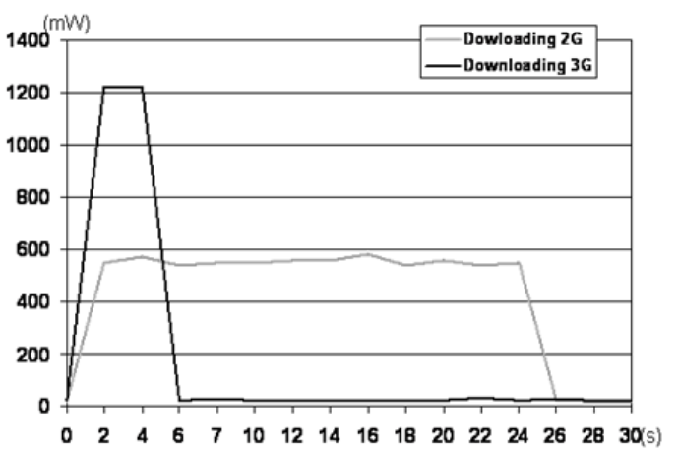

**Figure 4: Downloading consumption using 2G and 3G links. Reprinted from [17]**

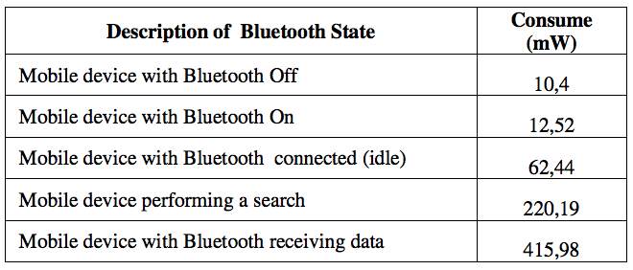

**Figure 5: Average consumption of Bluetooth technology. Reprinted from [17]**

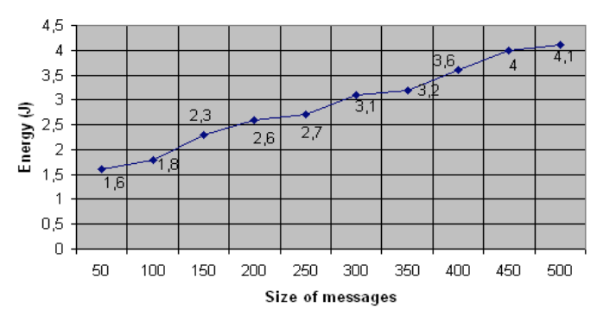

**Figure6: Energy consumption based on the SMS message size. Reprinted from [17]**

In [18] some actions were recommended to save energy. The first recommendation was for mobile applications to operate in networks that offer best-cost benefit rate. For applications that are used to send data (e.g. email applications), consider the alternative of delaying the sending of data, so that the maximum number or requests can be triggered at once. Moreover, applications must make use of parallel connections to transfer data, a strategy that would save a lot of energy. In [18] a mobile computing prototype called GMECloud that utilizes energy efficient mobile devices (e.g., smartphones and tablets) as computing resources is proposed. In the proposed prototype, the clients follow the server-client protocol flow chart described in Figure 7. As shown below, the mobile client’s application checks the status of the device, if the device is ready, it connects to the server. The status of the device is defined in terms of different characteristics, for example, the CPU usage, the device battery level, etc.

The server splits the job into smaller tasks; these tasks are then distributed to multiple clients. If the number of active clients is high, the server will assign to each client fewer tasks. This means that the time required by each client to finish the assigned tasks will be less.

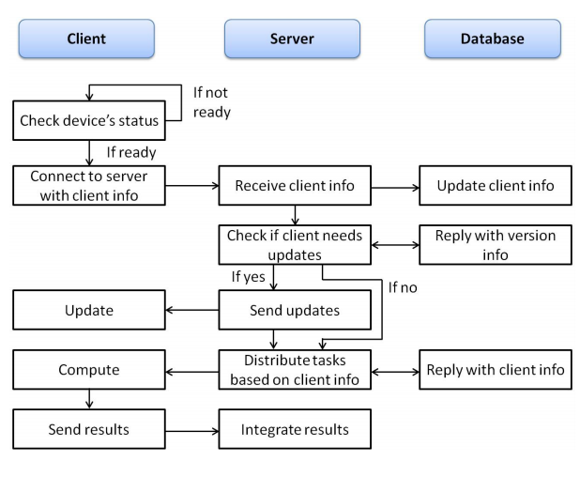

**Figure 7: Server-Client Protocol Flow Chart. Reprinted from [18]**

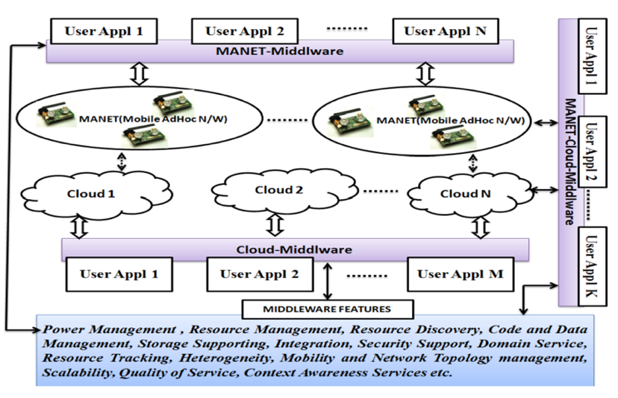

**Figure 8: Overview of Mobile-Cloud Computing based Middleware Architecture. Reprinted from [16]**

In [16], a novel approach is proposed where Middleware is coordinating between mobile and cloud computing techniques to achieve green computing for next generation. The major approaches of the Green Computing are Product longevity, Software and deployment optimization, Power management, Materials recycling, Telecommuting and Low performance computing.

A middleware is a software infrastructure, it binds together the applications, operating systems, network hardware, and network stacks. Its major task in this proposed architecture is to evaluate Data center power, Operating system support, Power supply, Storage, Video card, and Display.

Figure 8 shows the architecture of Mobile-Cloud Computing based Middleware for Green Computing. MANET is a set of wireless nodes, the data gathered by these nodes can be delegated on to Cloud or Middleware of Cloud based on the requirement and applications.

Green Cloud Computing System Architecture Technologies consist of five core technologies:

* Scalable Network Architecture
* Energy-efficient Cooling and Power Efficient System
* Modular Cloud Computing System
* Scalable Virtual Internet Appliance and
* Flash Memory Based Cloud Storage System

The purpose of this architecture is to reduce the unnecessary power consumption in a cloud computing environment.

Moving to [39], the main concern is to highlight the energy related issues as early as possible in the software development life cycle (SDLC) of an application making it more energy efficient and reducing the cost regarding energy consumption. This paper divides the green technology, as mentioned before, on all the stages of the software development life cycle (SDLC) of a given application. It starts with **Green software requirement specification**, means that there may be additional software requirements to maintain the developed software. Next, **Green Software design**; the main concern of the software developers is always the software structure, the modules needed, the software architecture, etc. While energy efficiency is a main part for a good software design, it’s rarely taken into consideration by software developers at this stage. Moving forward, **Green Software Implementation** focuses on reducing the application CPU consumption, the number of parameters used, and many other factors that affect the energy consumption. Regarding the testing phase, a **Green Software Testing** takes into consideration the number of people and the amount of equipment allocated to test the energy used by the application, of course based on predefined test cases related to energy consumption. Finally, **Green Software Maintenance** tends to perform regular maintenance tasks that will keep data transmission at optimal efficiency.

# Green Data Centers

## How Green Is A Data Center

Before taking a risk, an industry must first study the level of energy efficiency which is the level of energy consumed by the industry. Based on the quantitative results that issued from energy efficient measures we can decide what suitable techniques we can use in order to turn the data centers to become ecofriendly.

In [24], Mata-Toledo and Gupta mentioned two important metrics which are, the Power Usage Effectiveness (PUE) and Data Center Efficiency (DCE). They are computed based on the following equations. Where PUE is the Total power used by the data center building divided by the power used by the equipment team and DCE is one over PUE. They mentioned too an aid to the following analysis such as tools known as the “The Green Report” developed by RACKWISE. This tool is responsible for computing the PUE and DCE of a data center and is responsible for defining the resource amount consumed by each type such as servers, networks, and equipment. An example of a Green Report is illustrated in Figure 9.

However, Siso et al. [40] focused on metrics technique called CoolEmAll that focuses not only on Energy consumption but also on Heat-aware metrics. They pointed out, that the reason they introduced CoolEmAll metrics is because of the reason that standard metrics such as, CFD, PUE doesn’t allow any space for predication of energy performance to enhance the energy efficiency. And another goal that this metrics is that other metrics such as PUE evaluates efficiency of facilities and not IT equipment while CoolEmAll provides analysis tools for data centers efficiency according to IT equipment. This related metrics established by Siso et al. mainly focuses on heat-aware of a data center and hence tends to enhance performance directly from the point from which energy is originated, that’s why the metrics will be focused in resource usage, power consumption, heat-ware, and green consumption. So in order to optimize the performance a four level of scale will be analyzed and studied. So metrics will be applied on these four levels that are, node unit which is the smallest element of a data center (single CPU model), node group that consists of various node units (complete blade units or a rack unit consisting of 18 servers), rack level that is made up of elements in IT center such as, power supply units, and room of a data center that consists of a container filled of racks or even power distribution units.

Moreover, Wang and Khan [41] presented in their study more metrics in order to measure the consumption of energy performance in data centers. The aim of their study is to know how green a data center is through different matrices and measurements and according to that information possible techniques can be taken for a data center to go green. They pointed out that there are two methods for going green either to involve green requirements into building the infrastructure of the process or to green up the process of a working data center in every day usage. Before defining the performance metrics, a set of criteria must be met at first which are the following: technically sounds which mean that the metrics should be adaptable to various data center types, balanced system evaluation which specifies that the whole data center system, low cost to implement, and ease of use. They shed the light in their discussion on various types of matrices. Greenhouse gas emission which is mainly made up of CO2 is considered hard to measure due to the fact that, the outstanding infrastructure of a data center is complicated, and CO2 produced is triggered by many factors.

Another metrics handles the humidity for a reason that high humidity in a data center can cause hardware failure problems and will increase the cost of cooling solutions.

## Optimization Methodologies:

Moreover, after measuring the efficiency of a data center in an industry, there must be certain measures taken in order to come up with an ecofriendly data center.

In their study, Sari and Akkaya [42] mentioned that one of the greatest threats that affect green data centers can be divided into two groups. First threat, consists of the in ability to manage the cost crises that is born due to the divergence in determining the efficiency performance technique from one hand and the calculating the performance of the server. Another threat relates to data centers is the release of carbon dioxide that results from data centers to the atmosphere. Figure 10 presents carbon dioxide emissions compared between IT equipment and some countries.

The authors presented two methods of techniques into data centers to handle these threats. They first presented cooling method know as liquid cooling approach that is put into action its only limitation is that it is geographically dependent which means it must be located in cold areas so that cold water is formed that will reduce temperature and hence reduce the consumption of energy. Another cooling approach is known as direct cooling that is responsible for reducing energy consumption. It works by implementing of cooling coils into the rack to remove waste heat by transferring it into fluids rather that deploying it into the air. In addition, another technique is presented that relates to using energy efficiency servers which are achieved by using renewable energy resources to power up the data centers. Another way to produce efficient energy that was provided in this study is either to use of virtualization software through virtual machine or one can avoid the rapid change between alternating and direct current. The only limitation that these tests face is the need for a huge amount of tests before implementing the proposed techniques.

Furthermore, Ghani, Nikejad, Jeong [23] presented in their paper a series of techniques that enables a data center to go green by saving the consumption of energy. They managed to divide their field of work into four fields by presenting energy saving techniques for servers, energy saving techniques for networks, energy saving techniques for a combined environment of servers and networks, and finally by energy saving techniques by using renewable energy. As for servers, it’s known that server is the main consumer of energy in data center so establishing power saving environment

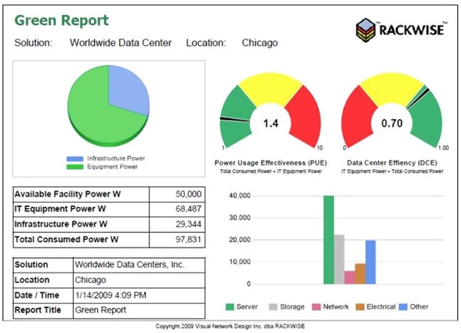

**Figure 9: The Green Report Tool [TGR (2009)]. Reprinted from [43]**



**Figure 10: Computers with countries and their carbon dioxide emission. Reprinted from [44].**

is vital in this area and it is covered through methodologies such as, server virtualization that tends to minimize the number of hardware in use and decrease the amount of functioning servers through making more than one virtual machine on server. Another technique known as dynamic power management that handles to puts down the computing servers when they are not in use that helps reduce power consumption. A a third technique known as dynamic voltage scaling that sets the CPU power according the level of load. Ghani et al. managed also to cover techniques that help to reduce energy consumption in networking fields due to that fact that networks infrastructure is the second consumer of energy after servers by utilizing 30% of energy used for powering data centers. One of the techniques is known as sleep mode that manages to switching of the networks resources or putting them to sleep mode whenever they are not in use. Virtual network embedding is technique that reduces energy consumption by assign virtual network resources on a small number of physical infrastructures while the idle network resources could be switched off. Also, an outstanding technique was mention know as green routing that tends to provide routing services to a fewer number of energy resources to maintain performance of network and reduce energy consumption. Moreover, mixed approaches for reducing energy consumption in data centers that deals with both networks and servers have shown great deal of reduction as for energy consumption could be reduced to 75% in data centers. Methodologies such as link state adaptation, server load consolidation, and network traffic consolidation.

## Discussion

**Figure 11: An overview of some studies addressing the awareness of green computing issues in higher education institutions**

|  |  |  |  |  |  |
| --- | --- | --- | --- | --- | --- |
| **University/Institute** | **Target group of Students** | **Focus and Objective** | **Findings** | **Year** | **Source** |
| University of Technology in Mauritius | School of Innovative Technologies and Engineering | Check and analyze the level of awareness of green computing focusing on student’s computing related activities and their computer literacy. The survey questions focused on the hardware aspects. | Students, in majority, are computer literate.  Students Lack knowledge of some major green computing practices (e.g. screen savers.) | 2012 | [28] |
| Botho College in Botswana | Students and academic employees | Measure and check awareness levels of computer users regarding the negative influence of IT on environment and with regards to green computing. | The need of green education to reach a green usage technology.  Changes behaviors and use of technology and IT can be reached by exalted education | 2012 | [31] |
| Higher Education Institute in Malaysia | Higher Education Institute ICT and non–ICT students in Malaysia. | The level of awareness, knowledge and practices of green computing. The study focused on Hardware aspects such as the usage of computer and its resources. | Students, mainly non-ICT, lack knowledge about green computing  Lack of knowledge among students regarding the benefits of green computing and its practices | 2015 | [47] |

All discussed articles in previous section managed to cover up a wide range of details relating to data centers and especially green data centers due to a fact that data centers are vital component of the computing industry and there is great need for the industry to have an ecofriendly data centers. Mata-Toledo and Gupta [24] managed in their article to give a brief explanation of techniques to compute performance of a data center but these techniques only relates to power usage metrics. However, Wang and Khan [41] managed to cover a wider range than Mata-Toledo, Gupta as they presented in their article matrices not only that it covers power usage but also covers, thermal metrics, humidity, and green house emission and the reason for this presentation was to show that although initiating data centers at the beginning may be costly, but metrics are needed in order to measure and balance between the green performance and computer performance and what is still missing here is a scales factor that measures how computing factors behave when green performance changes. In addition, to a new out coming metrics called CoolEmAll presented by Siso et al. [40], which they covered a new aspect of computing energy consumption in a data center which is presented to be a better approach the traditional power metrics (PUE, DCE). Furthermore, there are another set of topics that managed to cover some deal of techniques that are implemented to achieve a green computing data centers in four different scales where each scale presented a

that the paper different metrics. These metrics were implemented on four different data center parameters that are, temperature increase, heat dissipation requirements, power used by IT components, and workload driven by application types and management policies. Now these parameters assessed the acceptance of other matrices other than the traditional ones, and the analysis of imbalanced of temperature and other metrics such as power, power usage will permit informing about the cooling requirements of data center and at the same time permit the decrease of greenhouse gases emission. Sari, Akkaya [42] managed to present techniques such as the cooling methods and energy efficiency servers. But the problem is that the paper wasn’t able to cover a wider area especially in achieving optimization of servers. That’s why, Ghani, Nikejad, Jeong [23] in their paper covered domains of energy efficiency consumption not only in servers but also through networks infrastructure and a combination of both fields in addition to presenting renewable energy as a resource that could help in diminishing the consumption of energy in data centers due to a fact that networking infrastructure and server placement in data centers are growing rapidly that’s why an efficient optimization technique are required.

Therefore, before implementing any green technology in data centers a study that enables us to measure performance is essential to know how much green should we go and to know what is the performance of your IT infrastructure. And hence depending on the basis of measurement of IT infrastructure using precise metrics special techniques is to be taken to transform the environment of data center into a green environment.

# Green Computing In Education

Many work and studies have been made in order to improve the green computing awareness and practices in the education sector.

## Awareness on Green Computing in Education Sector

The awareness and knowledge of green computing have been addressed by many studies and different surveys where different target groups were surveyed. In [45], Manotas et al. studied the relationship between practitioners and research community, where they found that practitioners could be more effective in creating efficient applications that consider energy consumption.

In 2011, Kogelman conducted a study in which Information and Communication Technology (ICT) managers were surveyed about the use of hardware-focused energy efficient methods in organizations [46]. In [49], German software users were surveyed for a study that addressed the environmental issues of software.

|  |  |
| --- | --- |
| **Measure/Technique** | **Source** |
| **Online Learning:** reduce the pollution that results from students and faculty travels by adopting online learning techniques such as video conferencing and web conferencing.  **Implementing Green Computing in administration and in sharing information:** use of online examination systems instead of paper-based exams, using software application to submit student information such as grades and attendance, reduce the use of papers by introducing online applications, forms and petitions, introducing online system for fees payment, use of online brochures thus saving papers and conserving power.  **Saving electricity:** educational institutes should consider the huge power consumption that result from the use of computers on its different offices and classes. ENERGY STAR labeled computer equipment should be purchased and should replace energy inefficient equipment (e.g. LCD monitor instead of CRT one) | [49] |
| **Upgrading Computers:** upgrading specific components (CPU, system memory) in the computer in order to prolong the lifecycle computers and improve performance.  **Power saving modes:**  computer power consumption can be managed in an efficient way by using the most “green” and efficient computer power saving mode. Different modes include sleep mode, hibernate mode, system standby mode and hard disk sleep mode. The Hibernate mode proved to be the most effective among other as it power off the computer completely.  **Eliminate Phantom Loads:** by using of power strip devices that power off in an automatic way powered off devices that are plugged into the strip. | [50] |
| **Virtual Desktop Infrastructure (VDI):** exploiting the green benefits of virtualization (operation efficiency, compatibility, ease of management, simplicity of deployment, low carbon emissions etc.) by implementing VDI in educational institutes. The implementation of VDI has proved to be power efficient as it saves power and consumes low energy compared to non-virtual infrastructure. | [51] |

**Figure 12: An overview of some green computing measures to be used by educational institutes**

Results showed that although environmental issues seem to be topics of interest to software users, software’s environmental issues are not part of these interests [29]. The findings of such studies prove the importance of spreading green computing awareness from the early stages of people lives i.e. in the early stages of education. It is important for educational institutions to start investigating the importance of saving the environment at an early stage [29].

Many studies were conducted in the literature to comprehend the level of knowledge and awareness of green computing among university students [28, 31, 47]. In [28], Dookhitran et al. conducted a study to check the level of awareness of green computing among students at the University of Technology in Mauritius. The survey was designed for students of the School of Innovative Technologies and Engineering. The main goal of the study was to determine the levels of awareness and knowledge in green computing and its practices [28]. In [47], Selyamani and Ahmad conducted a study that addressed the student’s awareness of green computing issues in higher education institutes focusing mainly on hardware aspects. The survey was undertaken by students from Higher education institutes in Malaysia. The study findings indicated that students, mainly non-ICT, lack the green computing knowledge. In [31], students and academic staff at Botho College in Botswana were surveyed in order to check and measure the levels of awareness regarding green computing and the negative influences of IT on environment. The study was also conducted to check if any green computing policies are established in the institution. Interviews with staff of the IT department were also prepared and organized. The results showed that the level of awareness regarding green computing is low, and that no green computing policies are set in the institution. An overview of some studies addressing the awareness of green computing issues in higher education institutions is included in Figure 11.

## Approaches to create and raise awareness

The topic of creating and raising awareness in the education sector has been studied in the literature where different and many ideas have been published. According to [31], creating a website that contains different green computing information, procedures, policies and tips is one solution to create awareness among students in a university. Pang et al. called for the extending the aspects of green computing in the educational programs [44]. Dookhitram et al. proposed that environmental IT information can be spread by the information channels that are mainly used by the students [28]. Haraty et al. suggested engaging students in educational activities and including awareness campaigns in the educational curriculum [27]. In [48], Suryawanshi presented a number of techniques that raise the awareness of Green ICT such as: Including an obligatory green ICT program course in all universities, to train learners about the importance of implementing green practices by starting Green Computing Certification course, to present rewards for educational institutions and educators (Green Institute, Green Teacher) that best embrace green practices efficiently as a motivation, effective promotion of green ICT practices, and encouraging faculty and students to choose webinars instead of traveling and adopting online education mechanisms in universities that will lead to less carbon footprint [48].

## Green Computing Techniques to be used by educational institutes

A lot of studies have been conducted and ideas have been published in the literature about the measures that needs to be taken by educational institutes in order to improve the practicing of green computing [49, 50, 51]. An overview of some measures is provided in Figure 12.

Many work and studies have been made in order to improve the green computing awareness and practices in the education sector. However, more green awareness should be raised among students. Educators and educational institutions have a crucial role to play in order to promote and spread green computing awareness among students. Moreover, many measures should be taken and many techniques should be used in order to practice real green computing in educational institutes.

# Conclusion

Technology has become a major cause for global warming whenever treated inefficiently. A huge urge is needed to save our environment before it’s too late. In this paper, we went over different approaches to “GO GREEN”. We also addressed the software engineering models for green computing, and the four different perspectives for this topic: Green cloud computing, Green mobile development, Green data centers and the importance of green computing in educational sector. As a consequence, the usage of green computing by normal people contributes to their harmonic existence in knowledge society, and this corresponds quite well to basic objectives of cognitonics [52]. To sum up, this paper is intended to be part of the research that have been ongoing to increase the awareness of people towards this topic and presents different approaches that will help whenever applied in software development.

REFERENCES

[1] New Global CO2 Emissions Numbers Are In. They're Not Good. (n.d.). Retrieved from <https://www.wri.org/blog/2018/12/new-global-co2-emissions-numbers-are-they-re-not-good>

[2] S. Naumann, M. Dick, E. Kern, T. Johann, The GREENSOFT model: a reference model for green and sustainable software and its engineering, Sustain. Comp. Inf. Syst. 1 (4) (2011) 294-304.

[3] F. Berkhout, J. Hertin, Impacts of Information and Communication Technologies on Environmental Sustainability: Speculations and Evidence, Report to the OECD, 2001, http://www.oecd.org/dataoecd/4/6/1897156.pdf (accessed 2019-04-03).

[4] Mahmoud, S.S., Ahmad, I.: A green model for sustainable software engineering 2013. Int. J. Soft. Eng. Appl. 7(4), 55–74 (2013)

[5] E. Capra, G. Formenti, C. Francalanci, S. Gallazzi, The impact of MIS software on IT energy consumption, in: 18th European Conference on Information Systems, June 7–9, 2010, Pretoria, South Africa, 2010, http://web.up.ac.za/ecis/ECIS2010PR/ECIS2010/Content/Papers/0073.R1.pdf (accessed 2010-10-25).

[6] A. Atrey, N. Jain, N. Iyengar, A study on green cloud computing**,** Int. J. Grid Distrib. Comp. (2013), pp. 93-102.

[7] B. Dougherty, J. White, and D. C. Schmidt, “Model-driven auto-scaling of green cloud computing infrastructure,” Future Generation Computer Systems, vol. 28, no. 2, pp. 371–378, 2012.

[8] Gai, Keke, et al. “Dynamic energy-aware cloudlet-based mobile cloud computing model for green computing,” Journal of Network and Computer Applications, vol. 59, pp. 46-54, 2016. [9] Mahmoud MME, Rodrigues JJPC, Saleem K, Al-Muhtadi J, Kumar N, Korotaev V.Towards energy-aware fog-enabled cloud of things for healthcare. Comput Electr Eng 2018;67:58–69.

[9] X. Xu, Q. Zhang, S. Maneas, S. Sotiriadis, and C. Gavan, “Simulation Modelling Practice and Theory. VMSAGE: A virtual machine scheduling algorithm based on the gravitational effect for green Cloud computing,” Simul. Model. Pract. Theory, no. June, pp.1–17, 2018. <https://doi.org/10.1016/j.simpat.2018.10.006>

[10] Y. Zhao-Hui, J. Qin-Ming, Power management of virtualized cloud computing platform, Chin. J. Comput. 6 (2012) 015.

[11] Mahmoud MME, Rodrigues JJPC, Saleem K, Al-Muhtadi J, Kumar N, Korotaev V.Towards energy-aware fog-enabled cloud of things for healthcare. Comput Electr Eng 2018;67:58–69.

[12] Verma S, Kumar Yadav A, Motwani D, Raw RS, Singh HK. An efficient data replication and load balancing technique for fog computing environment. In: Computing for sustainable global development (INDIACom), 2016 3rd international conference on, IEEE, New Delhi, India, 16–18 March; 2016. p. 2888–95..

[13] Salama, A.I., Energy-efficient cloud computing application solutions and architectures..

[14] Younge, A.J., et al. Efficient resource management for cloud computing environments. in Green Computing Conference, 2010 International. 2010. IEEE.

[15] Haraty, Ramzi A. and Gongzhu Hu. *Software Process Models: A Review and Analysis.* International Journal of Engineering and Technology, Volume 7, Number, 2.29, pp. 325-331, DOI: [10.14419/ijet.v7i2.29.13206](http://dx.doi.org/10.14419/ijet.v7i2.29.13206),2018.

[16] Naikodi, Dr.Chandrakant. (2013). Green Computing and Mobile-Cloud-Computing Inspired Middleware for Next Generation. International Journal of Advanced Research in Computer Science and Electronics Engineering (IJARCSEE). 2. pp-542.

[17] de Siebra, Clauirton & Costa, Paulo & Marques, Rafael & Santos, André & Silva, Fabio. (2011). Towards a green mobile development and certification. 288-294. 10.1109/WiMOB.2011.6085386.)

[18] Ba, H., Heinzelman, W., Janssen, C., & Shi, J. (2013). Mobile computing - A green computing resource. *2013 IEEE Wireless Communications and Networking Conference (WCNC)*. doi:10.1109/wcnc.2013.6555295

[19] B.-G. Chun, S. Ihm, P. Maniatis, M. Naik, and A. Patti, “Clonecloud: elastic execution between mobile device and cloud,” in Proceedings of the sixth conference on Computer systems, ser. EuroSys ’11. New York, NY, USA: ACM, 2011, pp. 301–314. [Online]. Available: <http://doi.acm.org/10.1145/1966445.1966473>

[20] M. Satyanarayanan, P. Bahl, R. Caceres, and N. Davies, “The case for vm-based cloudlets in mobile computing,” Pervasive Computing, IEEE, vol. 8, no. 4, pp. 14 –23, oct.-dec. 2009.

[21] E. Cuervo, A. Balasubramanian, D.-k. Cho, A. Wolman, S. Saroiu, R. Chandra, and P. Bahl, “Maui: making smartphones last longer with code offload,” in Proceedings of the 8th international conference on Mobile systems, applications, and services, ser. MobiSys ’10. New York, NY, USA: ACM, 2010, pp. 49–62. [Online]. Available: http://doi.acm.org/10.1145/1814433.1814441.

[22] E. Chen, S. Ogata, and K. Horikawa, “Offloading android applications to the cloud without customizing android,” in Pervasive Computing and Communications Workshops (PERCOM Workshops),

[23] Ghani, I., Niknejad, N., & Jeong, S. R. (2015). Energy saving in green cloud computing data centers: A review. Journal of Theoretical & Applied Information Technology, 74(1)..

[24] Mata-Toledo, R., & Gupta, P. (2010). Green data center: how green can we perform. Journal of Technology Research, Academic and Business Research Institute, 2(1), 1-8.

[25] Elgelany, A., & Nada, N. (2013). Energy efficiency for data center and cloud computing: A literature review. Energy, 3(4).

[26] Uddin, M., Shah, A., Alsaqour, R., & Memon, J. (2013). Measuring efficiency of tier level data centers to implement green energy efficient data centers. Middle-East Journal of Scientific Research, 15(2), 200-207.

[27] Haraty, Ramzi & Bitar, Georges. (2019). Associating learning technology to sustain the environment through green mobile applications. Heliyon. Volume 5, Issue 1, (2019) e01141. doi: 10.1016/j.heliyon.2019. 01141.

[28] Dookhitram, Kumar & Narsoo, Jeetendre & S. Sunhaloo, M & Sukhoo, Aneerav & Soobron, M. (2012). Green computing: An awareness survey among University of Technology, Mauritius Students.

[29] Kern, Eva. (2018). Green Computing, Green Software, and Its Characteristics: Awareness, Rating, Challenges. 10.1007/978-3-319-65687-8_23.

[30] Yu Cai. 2010. Integrating sustainability into undergraduate computing education. In Proceedings of the 41st ACM technical symposium on Computer science education (SIGCSE '10). ACM, New York, NY, USA, 524-528. DOI: <https://doi.org/10.1145/1734263.1734439>

[31] Batlegang, Billy. (2012). GREEN COMPUTING: STUDENTS, CAMPUS COMPUTING AND THE ENVIRONMENT- A CASE FOR BOTSWANA. 10.13140/RG.2.1.2227.9528.

[32] S. Wang, H. Chen and W. Shi, “SPAN: A software power analyzer for multicore computer systems”, Sustainable Computing: Informatics and Systems, vol. 1, no. 1, (2011), pp. 23-34.

[33] N. Amsel, Z. Ibrahim, A. Malik and B. Tomlinson, “Toward sustainable software engineering: NIER track”, 2011 IEEE 33rd International Conference on Software Engineering (ICSE), (2011), pp. 976-979.

[34] Computer center powernap plan could save 75% of data center energy, 2009. http://www.sciencedaily.com/releases/2009/03/090305164353.htm (accessed 11.04.2019).

[35] E. Rubin, A. Rao, C. Chen, Comparative assessments of fossil fuel power plants with CO2 capture and storage, in: Proceedings of 7th International Conference on Greenhouse Gas Control Technologies, vol. 1, 2005, pp. 285–294.

[36] C. Cassar, Electric power monthly, 2010. http://www.eia.doe.gov/cneaf/electricity/epm/epm_sum.html, (accessed 11.04.2019)

[37] Alejandro Fernández-Montes, Damián Fernández-Cerero, Luis González-Abril, Juan Antonio Álvarez-García, Juan Antonio Ortega, Energy wasting at internet data centers due to fear,Pattern Recognition Letters,Volume 67, Part 1,2015,Pages 59-65,ISSN 0167-8655,https://doi.org/10.1016/j.patrec.2015.06.018.

[38] Shi Y, Ding G, Wang H, Roman HE, Lu S. The fog computing service for healthcare. In: 2015 2nd international symposium on future information and communication technologies for ubiquitous healthcare (Ubi-HealthTech), Beijing, China, 28–30 May; 2015. p. 1–5.

[39] Kirmani, M. M. (2017). *Integrated approach for efficient mobile application*

*development using Cloud Computing and Green SDLC: A Study*[PDF]. Srinagar, J&K, India: Sher-e-Kashmir University of Agricultural Sciences & Technology of Kashmir.

[40] Sisó, L., Salom, J., Jarus, M., Oleksiak, A., & Zilio, T. (2013). Energy and heat-aware metrics for data centers: Metrics analysis in the framework of CoolEmAll project. International Conference on Cloud and Green Computing. 428-434.

[41] Wang, L., & Khan, S. U. (2013). Review of performance metrics for green data centers: A taxonomy study. The Journal of Supercomputing, 63(3), 639-656.

[42] Sari, A., & Akkaya, M. (2015). Security and optimization challenges of green data centers. International Journal of Communications, Network and System Sciences, 8(12), 492.

[43] TGR (2009), RACKWISETM, The Green Report

[44] Pang, Candy & Hindle, Abram & Adams, Bram & Hassan, Ahmed E.. (2015). What Do Programmers Know about Software Energy Consumption?. IEEE Software. 33. 1-1. 10.1109/MS.2015.83.

[45] Manotas, Irene & Bird, Christian & Zhang, Rui & Shepherd, David & Jaspan, Ciera & Sadowski, Caitlin & Pollock, Lori & Clause, James. (2016). An empirical study of practitioners' perspectives on green software engineering. 237-248. 10.1145/2884781.2884810.

[46] Kogelman C-A (2011) CEPIS Green ICT Survey – Examining Green ICT Awareness in Organisations: Initial Findings. Carol-Ann Kogelman on behalf of the CEPIS Green ICT Task Force. CEPIS UPGRADE XII(4):6–10

[47] Selyamani S, Ahmad N (2015) Green Computing: The Overview of Awareness, Practices and Responsibility Among Students in Higher Education Institutes. Journal of Information Systems Research and Innovation Zhang C, Hindle A, German DM (2014) The Impact of User Choice on Energy Consumption. Software, IEEE 31(3):69–75

[48] Suryawanshi, Kavita. (2019). Green Information and Communication Technology Techniques in Higher Technical Education Institutions for Future Sustainability: Proceedings of ICDMAI 2018, Volume 2. 10.1007/978-981-13-1274-8_3.

[49] Agarwal, S., KaustuviBasu, & Nath, A. (2013). Green Computing and Green Technology based teaching learning and administration in Higher Education Institutions..

[50] Talebi, Mujtaba & Way, Thomas. (2009). Methods, metrics and motivation for a green computer science program. ACM SIGCSE Bulletin. 41. 362-366. 10.1145/1508865.1508995.

[51] Agarwal, Shalabh & Biswas, Rana & Nath, Asoke. (2014). Virtual Desktop Infrastructure in Higher Education Institution: Energy Efficiency as an Application of Green Computing. 601-605. 10.1109/CSNT.2014.250.

[52] Fomichov V. A., Fomichova O. S. 2012.  [A Contribution of Cognitonics to Secure Living in Information Society](https://publications.hse.ru/view/66933268). Informatica. An International Journal of Computing and Informatics (Slovenia). Vol. 36. No. 2. P. 121-130.